

Ordinary Council Meeting

10 April 2024

Agenda
Notice is hereby given of Ordinary Meeting of Council to be held in the Council Chambers, City of Kwinana Administration Centre commencing at 5.30pm.
Wayne Jack
Chief Executive Officer
Members of the public who attend Council meetings should not act immediately on anything they hear at the meetings, without first seeking clarification of Council’s position. Persons are advised to wait for written advice from the Council prior to taking action on any matter that they may have before Council.

Agendas and Minutes are available on the City’s website www.kwinana.wa.gov.au

Order Of Business
1 Opening and Announcement of Visitors 4
2 Welcome to Country and Acknowledgement of Country 4
3 Dedication 5
4 Attendance, Apologies, Leave(s) of Absence (Previously Approved) 5
5 Public Question Time 5
6 Receiving of Petitions, Presentations and Deputations 5
6.1 Petitions 5
6.2 Presentations 6
6.3 Deputations 6
7 Confirmation of Minutes 7
7.1 Minutes of the Ordinary Council Meeting held on 27 March 2024 7
8 Declarations of Interest (Financial, Proximity, Impartiality – both Real and Perceived) by Members and City Officers 8
9 Requests for Leave of Absence 8
10 Items brought Forward for the Convenience of those in the Public Gallery 8
11 Any Business Left Over from Previous Meeting 8
12 Recommendations of Committees 8
13 Enbloc Reports 8
14 Reports – Community 9
14.1 Renewal application for a Premises Certificate for Gaming - Kwinana Senior Citizens Centre 9
14.2 Community Sporting and Recreation Facilities Fund (CSRFF) Application - Southern Districts BMX Club 23
15 Reports – Economic 28
15.1 Application for Rate Exemption - Rate Assessment A9345 - Good Samaritan Industries 28
15.2 Locality Change Request - Lot 9082 Runnymede Gate, Leda - Stage 49 The Village at Wellard 69
16 Reports – Natural Environment 79
17 Reports – Built Infrastructure 79
18 Reports – Civic Leadership 79
19 Notices of Motions of which Previous Notice has been Given 79
20 Notice of Motions for Consideration at the Following Meeting if Given during the Meeting 79
21 Late and Urgent Business 79
22 Reports of Elected Members 79
23 Answers to Questions which were taken on Notice 79
24 Mayoral Announcements 79
25 Confidential Items 79
26 Close of Meeting 79

1 Opening and Announcement of Visitors
Presiding Member to declare the meeting open and welcome all in attendance.

Presiding Member to announce that the Ordinary Council Meeting is being live streamed and recorded in accordance with the City’s Live streaming and Recording Council Meetings policy.

By being present at this meeting, members of the public consent to the City recording and livestreaming their image and/or voice.

2 Welcome to Country and Acknowledgement of Country
Councillor Barry Winmar to present the Welcome to Country:
“Ngullak nyinniny kooralong koora ngullak noitj nidja noongar boodjar. Noongar moort djoorapiny nyinniny nidja ngulla quopadok noongar boodjar kooralong.
From the beginning of time to the end, this is Noongar Country. Noongar people have been graceful keepers of our nation for many, many years.
Djinanginy katatjin djoorapiny nidja weern noongar boodjar ngalla mia mia boorda.
Look, listen, understand and embrace all the elements of Noongar Country that is forever our home.
Kaya wandju ngaany koort djoorpiny nidja Noongar boodjar daadjaling waankganinyj Noongar Boodjar.
Hello and welcome my heart is happy as we are gathered on country and meeting here on Noongar Country”

Presiding Member to read the Acknowledgement of country:

“It gives me great pleasure to welcome you all here and before commencing the proceedings, I would like to acknowledge that we come together tonight on the traditional land of the Noongar people and we pay our respects to their Elders past and present.”

3 Dedication
Councillor Michael Brown to read the dedication:

“May we, the Elected Members of the City of Kwinana, have the wisdom to consider all matters before us with due consideration, integrity and respect for the Council Chamber.

May the decisions made be in good faith and always in the best interest of the greater Kwinana community that we serve.”

4 Attendance, Apologies, Leave(s) of Absence (Previously Approved)
Apologies:

Councillor M Rowse

Leave(s) of Absence (previously approved):

Nil

5 Public Question Time
In accordance with the Local Government Act 1995 and the Local Government (Administration) Regulations 1996, any person may during Public Question Time ask any question.

In accordance with Regulation 6 of the Local Government (Administration) Regulations 1996, the minimum time allowed for Public Question Time is 15 minutes.
A member of the public who raises a question during Question Time is to state his or her name and address.

Members of the public must provide their questions in writing prior to the commencement of the meeting. A public question time form must contain all questions to be asked and include contact details and the form must be completed in a legible form.

Please note that in accordance with Section 3.4(5) of the City of Kwinana Standing Orders Local Law 2019 a maximum of two questions are permitted initially. An additional question will be allowed by the Presiding Member if time permits following the conclusion of all questions by members of the public.

6 Receiving of Petitions, Presentations and Deputations

6.1 Petitions

A petition must –
be addressed to the Mayor;
be made by electors of the district;
state the request on each page of the petition;
contain at least five names, addresses and signatures of electors making the request;
contain a summary of the reasons for the request;
state the name of the person to whom, and an address at which, notice to the petitioners can be given; and
be respectful and temperate in its language and not contain language disrespectful to Council.

The only motion which shall be considered by the Council on the presentation of any petition are –
that the petition be received;
that the petition be rejected; or
that the petition be received and a report prepared for Council.

6.2 Presentations

In accordance with Clause 3.6 of the Standing Orders Local Law 2019 a presentation is the acceptance of a gift, grant or an award by the Council on behalf of the local government or the community.

Prior approval must be sought by the Presiding Member prior to a presentation being made at a Council meeting.

Any person or group wishing to make a presentation to the Council shall advise the CEO in writing before 12 noon on the day of the meeting. Where the CEO receives a request in terms of the preceding clause the CEO shall refer it to the presiding member of the Council committee who shall determine whether the presentation should be received.

A presentation to Council is not to exceed a period of fifteen minutes, without the agreement of Council.

6.3 Deputations

In accordance with Clause 3.7 of the Standing Orders Local Law 2019, any person or group of the public may, during the Deputations segment of the Agenda with the consent of the person presiding, speak on any matter before the Council or Committee provided that:
the person has requested the right to do so in writing addressed to the Chief Executive Officer by noon on the day of the meeting.
setting out the agenda item to which the deputation relates;
whether the deputation is supporting or opposing the officer’s or committee’s recommendation; and
include sufficient detail to enable a general understanding of the purpose of the deputation.
A deputation to Council is not to exceed a period of fifteen minutes, without the agreement of Council.

7 Confirmation of Minutes

7.1 Minutes of the Ordinary Council Meeting held on 27 March 2024

Recommendation
That the Minutes of the Ordinary Council Meeting held on 27 March 2024 be confirmed as a true and correct record of the meeting.

8 Declarations of Interest (Financial, Proximity, Impartiality – both Real and Perceived) by Members and City Officers
Section 5.65(1) of the Local Government Act 1995 states:

A member who has an interest in any matter to be discussed at a council or committee meeting that will be attended by the member must disclose the nature of the interest —
in a written notice given to the CEO before the meeting; or
at the meeting immediately before the matter is discussed.

Section 5.66 of the Local Government Act 1995 states:

If a member has disclosed an interest in a written notice given to the CEO before a meeting then —
before the meeting the CEO is to cause the notice to be given to the person who is to preside at the meeting; and
at the meeting the person presiding is to bring the notice and its contents to the attention of the persons present immediately before the matters to which the disclosure relates are discussed.

9 Requests for Leave of Absence

10 Items brought Forward for the Convenience of those in the Public Gallery

11 Any Business Left Over from Previous Meeting

12 Recommendations of Committees
Nil

13 Enbloc Reports

14 Reports – Community

14.1 Renewal application for a Premises Certificate for Gaming - Kwinana Senior Citizens Centre

Summary

The Kwinana Senior Citizens Centre has made an application (Attachment A) to the City of Kwinana (the City) to renew the approval of the premises for bingo activities at the Senior Citizens Centre situated at Lot M1040 (17) Harley Way, Medina, which is due to expire on 17 April 2024.

As part of the application process for the Department of Racing, Gaming and Liquor (DRGL), a Certificate of Local Government Authority (Attachment B) is required to be issued in accordance with Section 55 of the Gaming and Wagering Commission Act 1987 certifying that the premises conforms with the required environmental health and planning legislations. The renewal premises application for a gaming premises certificate (Attachment C) is required to be signed by the City as the owner of the premises.

Renewal application for a premises certificate

The gaming activities in the form of bingo facilitate socialisation and participation and have not resulted in complaints or known incidents of anti-social behaviour. Council approval is therefore sought to complete the required local government certification and renewal premises application, which precedes the determination by the DRGL.

Officer Recommendation

That Council authorise the CEO to complete the Certificate of Local Government Authority, at Attachment B and renewal premises application at Attachment C to submit to the Department of Racing, Gaming and Liquor for their determination on the Kwinana Senior Citizens Centre renewal application for a gaming premises certificate.

Voting Requirement

Simple majority

Discussion

The Kwinana Senior Citizens Centre holds an existing premises approval for gaming, which is due to expire on 17 April 2024 and is seeking to renew the approval. This is being requested by application for approval of the premises for gaming to be conducted in the Main Hall of the premises for a five-year period from the date of approval by the DRGL.

Subsection 3 of Section 55 of the Gaming and Wagering Commission Act 1987 specifies that the grant of a premises approval for gaming requires:

a) a local government report to certify that conformance requirements to the Health (Miscellaneous Provisions) Act 1911, to the relevant Act relating to sewerage and drainage and to any subsidiary legislation made under those Acts or the Local Government Act 1995; and
b) a report from the authority responsible for local planning matters affecting the premises certifying that the proposed or actual use does not contravene any written law relating to local planning; or where a proposed use will not contravene such a written law only if a specified consent be given, whether or not that consent will be given and as to any conditions relating to that consent.

There is no delegation in place for an officer to complete the Section 55 Certificate of Local Government Authority. The certificate requires the local government to state that the part of the premises, which is subject to the application, conforms with the Health (Miscellaneous Provisions) Act 1911 and the use of the premises for gaming activities does not contravene City Planning matters.

To facilitate Council’s decision, the following supporting information is provided:

Conformance with the Health (Miscellaneous Provisions) Act 1911 –

1. A Certificate of Approval was issued to the Kwinana Senior Citizens Centre on 17 April 2009 pursuant to Section 178(1) of the Health (Miscellaneous Provisions) Act 1911 for the premises including the main hall for a maximum of 252 persons for the purposes of hall, meeting and dining use. Gaming use is covered under hall.
2. An inspection of the premises by an Environmental Health Officer on 11 March 2024 demonstrated compliance with the requirements of the Health (Public Buildings) Regulations 1992. These inspections are conducted on a regular basis to ensure ongoing compliance.
3. The premises is connected to the main sewers and there are no further local government requirements in relation to sewage and drainage at the premise.

Local planning matters affecting the premises –

1. The subject land is zoned Commercial under the Town Planning Scheme No. 2
2. The proposed gaming activities do not contravene the City’s Town Planning matters.

Following a request for information from the City, the applicant informed the City that:

• Bingo is being held every Wednesdays from 12.30pm to 3.00pm.
• Attendance is 15-30 persons on each day.
• The purpose of these sessions is to provide an activity that seniors enjoy as well as the opportunity for social interaction with similar interests.

It is therefore recommended that Council authorise the CEO issue a Section 55 Certificate of Local Government Authority supporting the Kwinana Senior Citizens Centre’s application to be further determined for approval by the DRGL.

Strategic Implications

This proposal will support the achievement of the following outcome/s and objective/s detailed in the Strategic Community Plan and Corporate Business Plan.

Strategic Community Plan
Outcome | Strategic Objective | Action in CBP (if applicable) | How does this proposal achieve the outcomes and strategic objectives?
4 – A unique, vibrant and healthy City that is safe, connected and socially diverse | 4.1 – Create, activate and manage places and local centres that are inviting, unique and accessible | 4.1.3 – Implement the Social Strategys | Gaming activities can provide opportunities for social connections.

Social Implications

This proposal will support the achievement of the following social outcome/s, objective/s and strategic priorities detailed in the Social Strategy.

Social Strategy
Social  Outcome | Objective | Strategic Priority | How does this proposal achieve the social outcomes, objectives and strategic priorities?
2 – Connected and Inclusive | 2.0 – Equitable and inclusive social connection and engagement with community life | 2.3 – Value and support the importance of social connections and consider how new and existing programs and services can contribute to reducing social isolation | This proposal will continue to support existing programs that facilitate social connections at the Kwinana Senior Citizens Centre.

Legal/Policy Implications

Gaming and Wagering Commission Act 1987
Section 55. Approving premises for gaming

(3) The Commission may in relation to any premises require an applicant for the grant of approval or the holder of the approval to produce to the Commission —
(a) a report from the local government of the district in which the premises are situated, certifying that those premises conform, or if not conforming in what respect they do not conform, to the Health (Miscellaneous Provisions) Act 1911, to the relevant Act relating to sewerage and drainage and to any subsidiary legislation made under those Acts or the Local Government Act 1995; and

(b) a report from the authority responsible for local planning matters affecting the premises certifying —
(i) that the proposed or actual use does not contravene any written law relating to local planning; or
(ii) where a proposed use will not contravene such a written law only if a specified consent be given, whether or not that consent will be given and as to any conditions relating to that consent;

Financial/Budget Implications

There are no financial or budget implications as a result of this report.

Asset Management Implications

There are no asset management implications as a result of this report.

Environmental/Public Health Implications

The recommendations of this report have the potential to help improve healthy behaviours through participation in activities.

However, they also have the potential to negatively impact on personal income and social support services.

Community Engagement

There are no community engagement implications as a result of this report.

Attachments
A. Attachment A - Gaming permit application - Kwinana Senior Citizens Centre - 17 Harley Way Medina
B. Attachment B - Certificate of Local Government Authority - Section 55 - Senior Citizens Centre Inc - 17 Harley Way Medina
C. Attachment C - Renewal Application for a Premises Certificate - Gaming Section 55 - Kwinana Senior Citizens Centre - 17 Harley Way Medina

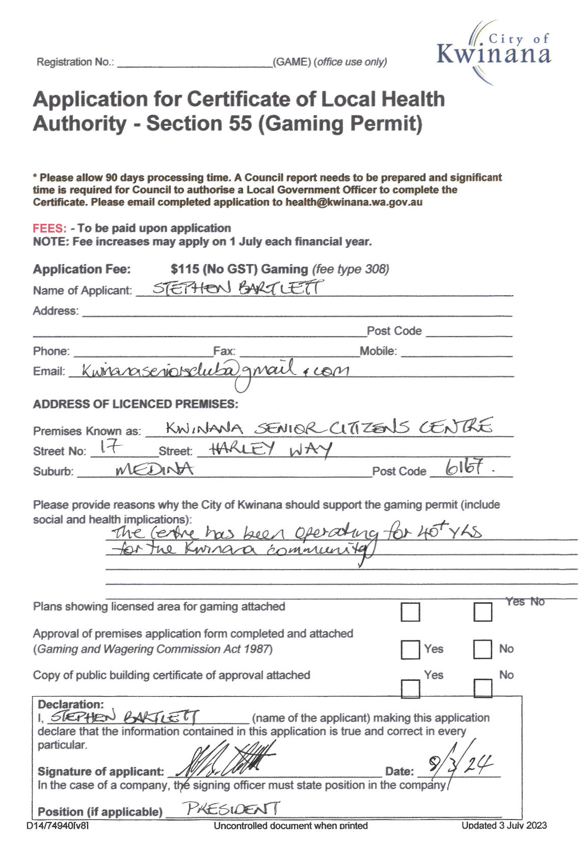
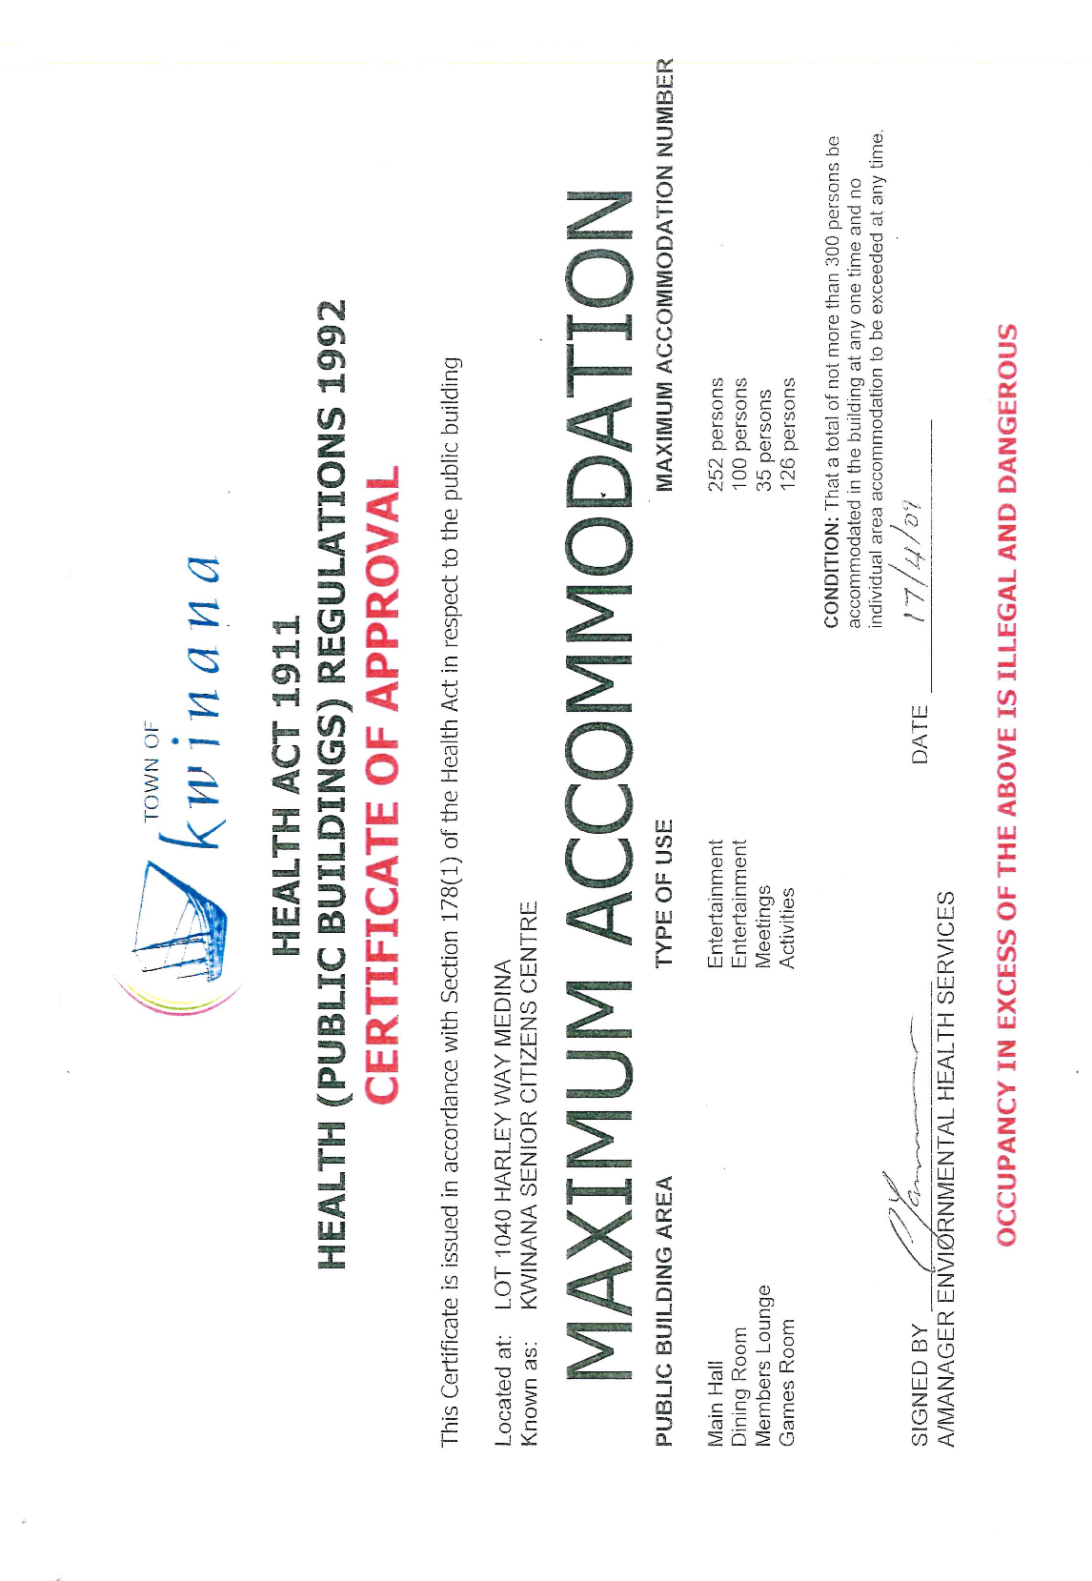

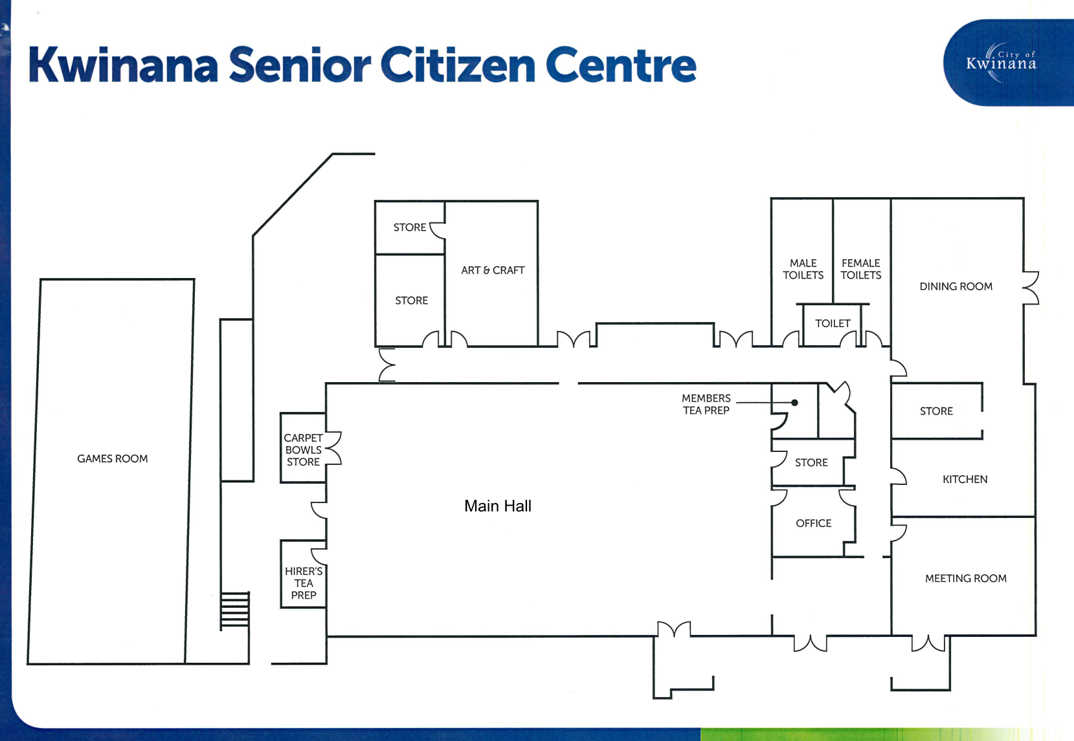





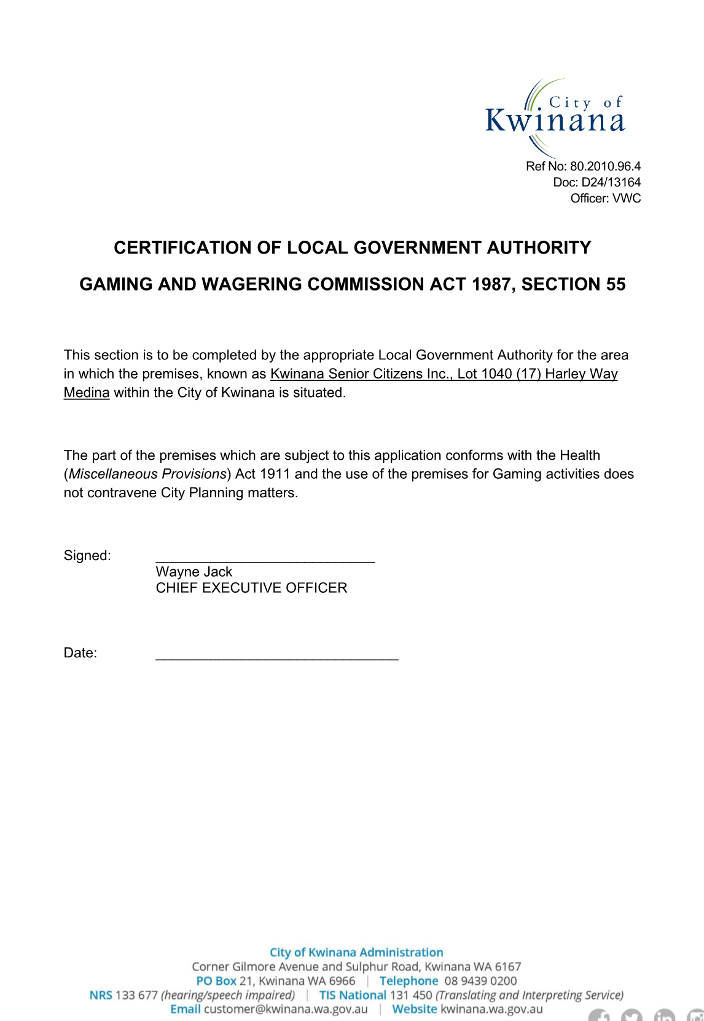



14.2 Community Sporting and Recreation Facilities Fund (CSRFF) Application - Southern Districts BMX Club

Summary

Southern Districts BMX Club have lodged a funding application with the Department of Local Government, Sport and Cultural Industries (DLGSC) through the Community Sporting and Recreation Facilities Fund (CSRFF) Program to support the replacement of the Club’s current starting gate. This report provides context to the application and outlines the requested Council support for the application.

Officer Recommendation

That Council endorse the CSRFF application by Southern Districts BMX Club for the replacement of their start gate.

Voting Requirement

Simple majority

Discussion

The BMX track, situated on Derbal Street in Medina, is the home of the Southern Districts BMX Club. The Club currently have a lease agreement with the City for the facility.

Southern Districts BMX operate all year round and attract between 60 to 90 riders on a standard race night. Their membership has seen a 12% increase since from 2020/2021, and it is envisioned that this will again rise after the 2024 Olympics.

The Club have identified the need for the replacement of the starting gate at the track. The current starting gate (attachment A) is approximately 20 years old and due to age and wear and tear, is nearing its end of life. Concerns has also been raised about the safety of the current gate. A new gate will meet required specifications, whilst also acting as a safety gate, which will provide a safer environment for riders (attachment B).

The replacement of the gate is considered a priority, due to the Club hosting the WA State Championships in September 2024. This event will see riders from all around the State convening in Kwinana. Based on 2023 attendance State Championships will see approximately 800 participants, plus spectators. This is a great opportunity for not only the track to be showcased, by Kwinana as a whole and will also have a positive impact on the local economy.

The new gate will be powered by electric over air (24-volt plug-in) system and operated with a remote control. The new gates will also be significantly quieter than the current gates.

Benefits of replacing the current starting gate include:

• Aesthetics and professionalism
The new gate is far more professional, and will be fit-for-purpose, therefore be more attractive to potential new riders.

• Improved Safety
The current gate has served the club well but has now reached its end of life. There have been safety risks identified with the current gate. The new gate will meet all relevant current specifications and safety standards.

• Reduction in noise
When in use, the current gate is noisy. The new gate will be significantly quieter, therefore providing not only a more positive experience to riders and spectators, but also ensuring the impact on surrounding residents is reduced.

To fund the project, the Southern Districts BMX Club has completed and submitted a CSRFF application which was endorsed by AusCycling, the State Sporting Association for BMX. The application was submitted to DLGSC in March 2024. A clause of the application is that the Club must receive endorsement from their Local Government Authority (LGA) for the funding application to be considered. It was noted in the application submitted to DLGSC that endorsement of the application by Council was pending, and the outcome of the endorsement will be provided retrospectively.

Based on quotes received by Southern Districts BMX Club the approximate cost of replacing the current start gate, along with associated works is approximately $43,000. This amount does not account for contingencies. CSRFF grants allow for up to half of the project cost to be funded. Information provided by the club states they have approximately $35,000 cash set aside for the project and have also allowed for volunteer hours to assist with the installation of the gate, potentially reducing the end cost. Volunteer hours are recognised as part of the Clubs dollar contribution to the project in the CSRFF application.

Strategic Implications

This proposal will support the achievement of the following outcome/s and objective/s detailed in the Strategic Community Plan and Corporate Business Plan.

Strategic Community Plan
Outcome | Strategic Objective | Action in CBP (if applicable) | How does this proposal achieve the outcomes and strategic objectives?
4 – A unique, vibrant and healthy City that is safe, connected and socially diverse | 4.1 – Create, activate and manage places and local centres that are inviting, unique and accessible | N/A – There is no specific action in the CBP, yet this report will help achieve the indicated outcomes and strategic objectives | By supporting the application for the replacement of the starting gates, the City will be encouraging the activation of the BXM track
4 – A unique, vibrant and healthy City that is safe, connected and socially diverse | 4.3 – Enhance opportunities for community to meet, socialise, recreate and build local connections4.1 – Create, activate and manage places and local centres that are inviting, unique and accessible | N/A – There is no specific action in the CBP, yet this report will help achieve the indicated outcomes and strategic objectives | By supporting the application for the replacement of the starting gates, the City will be encouraging physical recreation in the community

Social Implications

There are no social implications as a result of this proposal.

Legal/Policy Implications

There are no legal/policy implication as a result of this proposal.

Financial/Budget Implications

Under the current proposal, there are no financial/budget implications to the City for this project as it is proposed that the project will be half funded by the CSRFF funding, and half funded by Southern Districts BMX Club.

Asset Management Implications

There are no asset management implications for the City, as the maintenance and upkeep of the new starting gates will be the responsibility of Southern Districts BMX Club.

Environmental/Public Health Implications

The proposal has the potential to help improve the following determinants of health:

• Built Environment – Neighbourhood Amenity as the new starting gates would cause less noise than the current, older gates.
• Health Behaviours – Exercise and Participation as new gates will likely see an increase in participation rates at the Club.

Community Engagement

No formal community engagement has taken place regarding this application as there will be no direct negative impact to the surrounding community.

Attachments
A. Souther Districts BMX Club CSRFF Funding Application - Photos of Current and New Starting Gates - Attachment for Council Report - March 2024

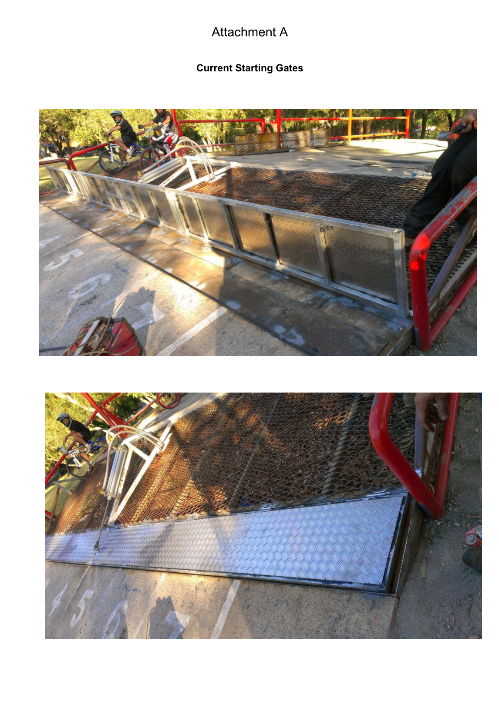
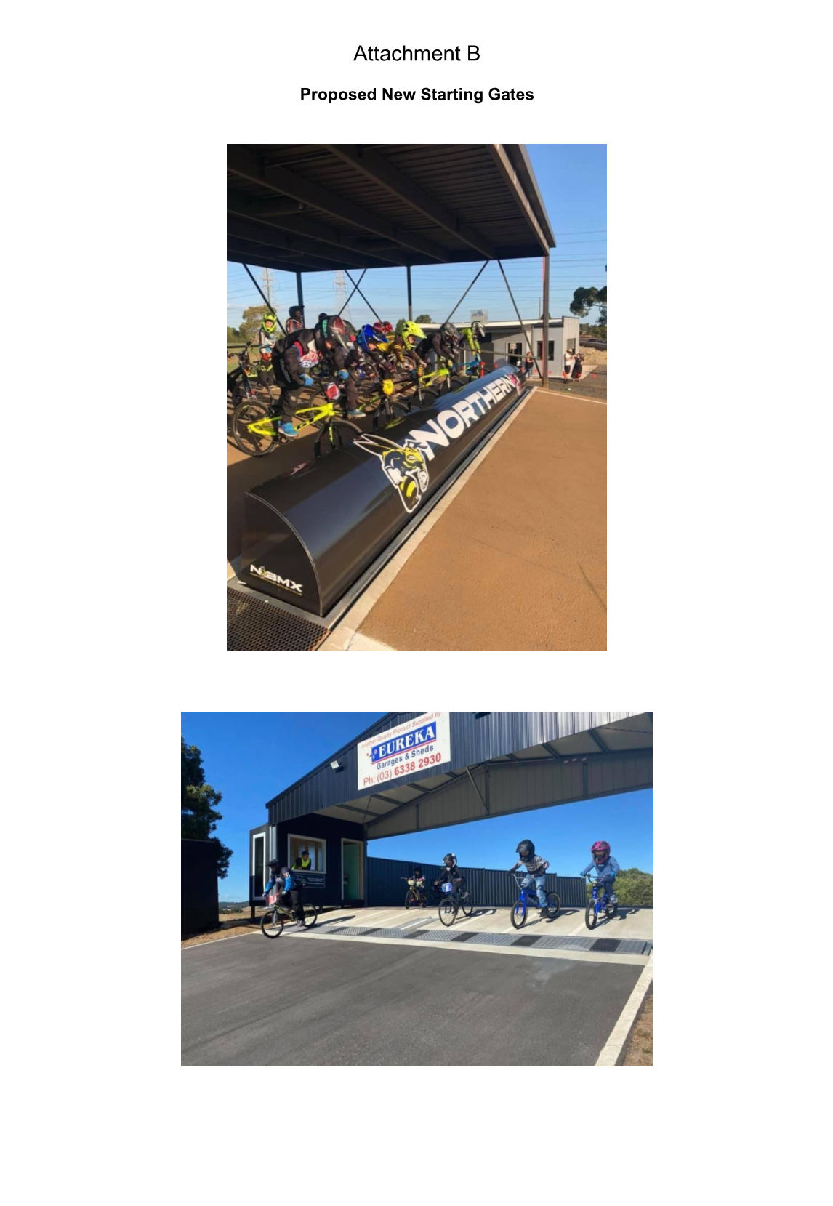

15 Reports – Economic

15.1 Application for Rate Exemption - Rate Assessment A9345 - Good Samaritan Industries

Summary

Good Samaritan Industries have submitted a request for rate exemption for a property situated on Meares Avenue within the City of Kwinana Town Centre on rate assessment A9345. The request attests that their properties are used for a ‘Charitable Purpose’ in accordance with Section 6.26(2)(g) of the Local Government Act 1995. The subject property is a privately owned asset but is leased to Good Samaritan Industries for the purposes of an opportunity shop, providing low-cost clothing and household products to the disadvantaged. All funds raised are used to provide services for the relief of poverty. This property has also previously been rate exempt when used for an identical purpose by Salvation Army in the 2021/2022 financial year.

Officer Recommendation

That Council approve the application for rate exemption for rate assessment A9345 for Good Samaritan Industries.

Voting Requirement

Simple majority

Discussion

Good Samaritan Industries trading as Good Sammy Enterprises is a community housing provider and have supplied the City with a copy of their ATO endorsement as an income tax exempt Public Benevolent Institution and registration as a not-for-profit Charitable Organisation under the Australian Charities and Not-for profit Commission. Good Samaritan Industries is a body corporate incorporated under the provisions of the Uniting Church in Australia Act 1976 (WA) and exists to provide employment choices for people with disabilities. This Mission contributes to enabling staff to achieve independence, self-worth, dignity and acceptance in society. Good Samaritan Industries currently employ some 360 people with various forms of disability within Good Samaritan Industries, and in the open workforce support 160+ people with disabilities within their roles and assist a further 250 people in seeking employment through internal courses and traineeships.

The subject property is a “Good Sammy” store, which sells recycled clothing and household goods. The ultimate purpose of the store is to train and employ people with disabilities in accordance with Good Samaritan’s Mission. All profits derived from the operation of the opportunity shop are channelled back into the community by the provision of support and community welfare programs.

Strategic Implications

There are no strategic implications as a result of this proposal.

Social Implications

There are no social implications as a result of this proposal.

Legal/Policy Implications

The Local Government Act 1995 deems certain land non-rateable under the statutes of Section 6.26 of the Act. Good Samaritan Industries is seeking exemption in accordance with subsection (2)(g) of the section, which states:

6.26. Rateable land
(1) Except as provided in this section all land within a district is rateable land.
(2) The following land is not rateable land –
(g) land used exclusively for charitable purposes.

Section 6.26 of the Local Government Act 1995 provides for rate exemptions based on exclusive charitable uses:

A ‘charitable purpose’ has a specified legal meaning, which has developed over the years by the courts and parliament. The courts have recognised many different charitable purposes and as society changes new charitable purposes are accepted.

Section 5 of the Commonwealth Charities Act 2013 states the definition of a charity as:

5.Definition of Charity
In any Act:
Charitable: an entity is charitable if the entity is a charity.
Example: A reference in an Act to a charitable trust is a reference to a trust that is a charity. Charity means an entity:
a) that is a not-for-profit entity; and
b) all of the purposes of which are:
i. charitable purposes (see Part 3) that are for the public benefit (see Division 2 of this Part); or
ii. purposes that are incidental or ancillary to, and in furtherance or in aid of, purposes of the entity covered by subparagraph

FINANCIAL/BUDGET IMPLICATIONS

If the rate exemption were to apply, the property would remain liable for the payment of ESL and any applicable refuse and recycling charges. If approved by Council, the City Administration will include the property in the City’s Register of Non-Rateable Properties and review their status on a triannual basis for continuation of exemption compliance.

The total exemption of rates would have a reduction in rate revenue of $5,642.63 for 2023/2024 financial year and would have similar financial implications for on-going financial years while the rate exemption is in effect.

ASSET MANAGEMENT IMPLICATIONS

There are no Asset Management implications as a result of this proposal.

Environmental/Public Health Implications

There are no environmental/public health implications as a result of this proposal.

Community Engagement

There are no Community Engagement implications as a result of this proposal.

Attachments
A. Application for Rates Exemption - A9345 - Good Samaritan Industries
B. Charitable Organisation Certificate - Good Samaritan Industries
C. Constitution - Good Samaritan Industries
D. Rate Exemption - Statutory Declaration - Good Samaritan Industries
E. Lease agreement - Good Samaritan Industries - A9345


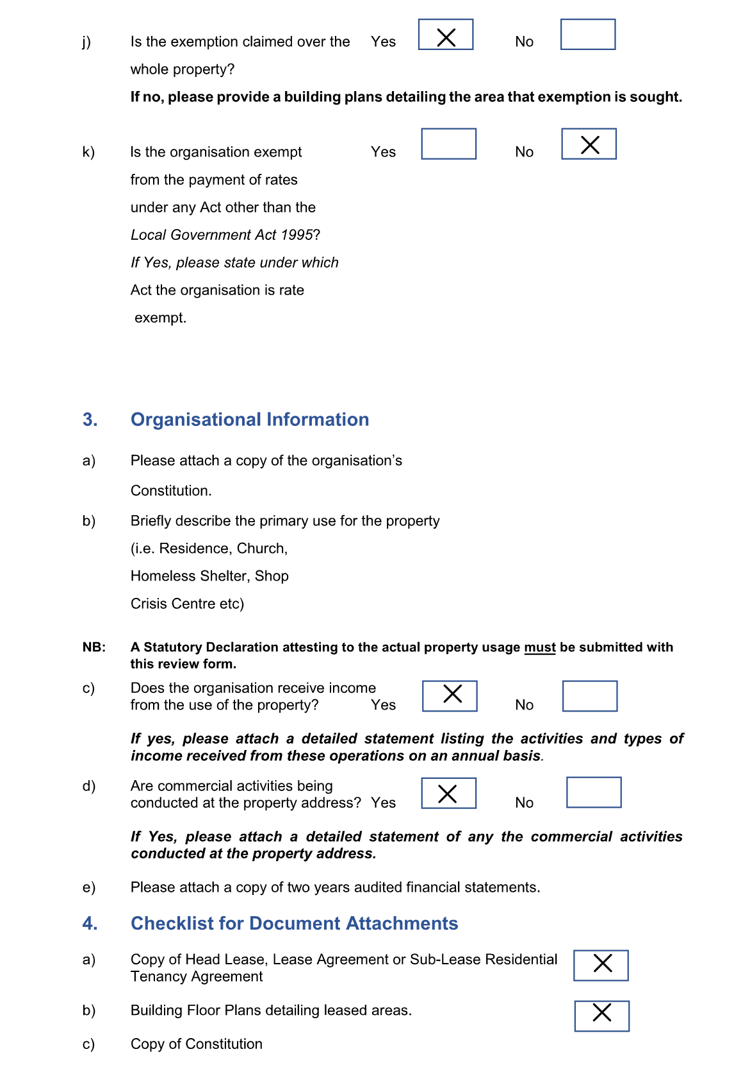
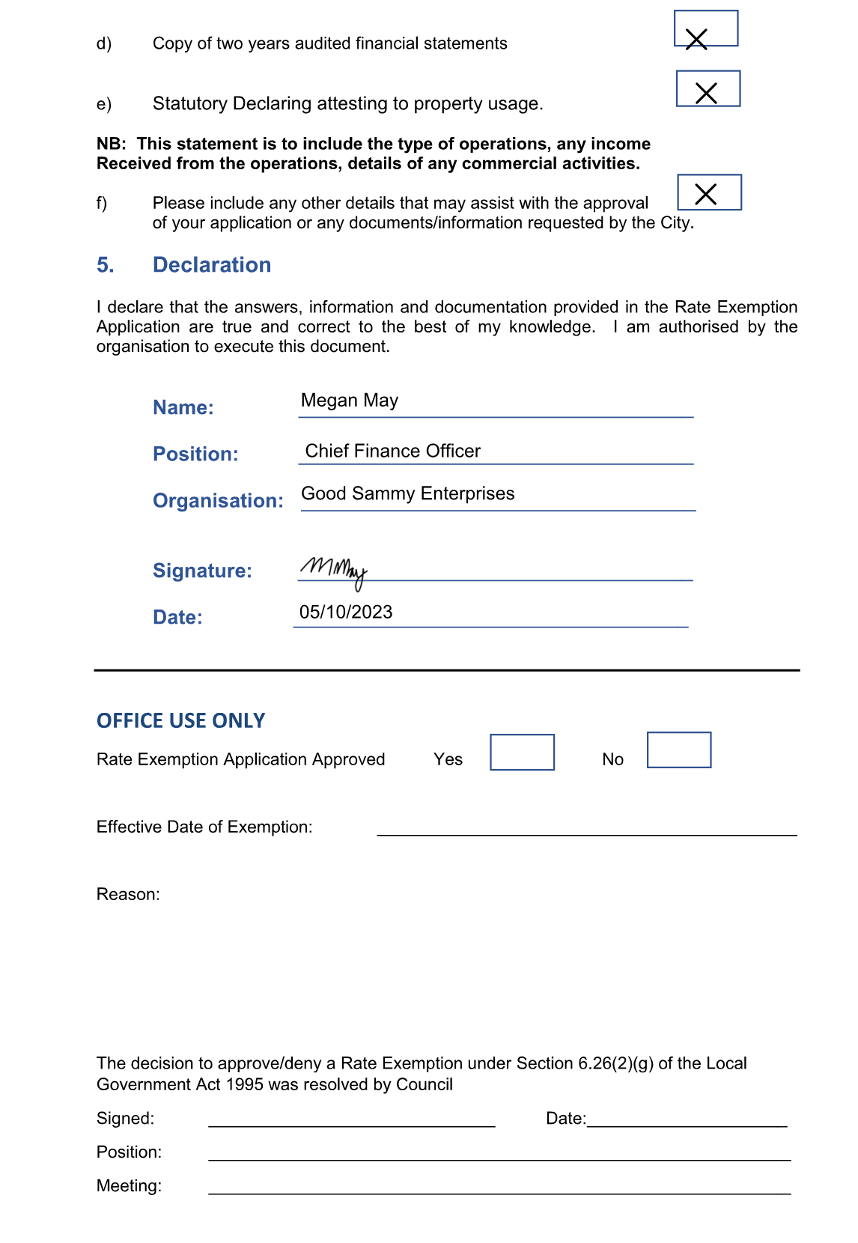

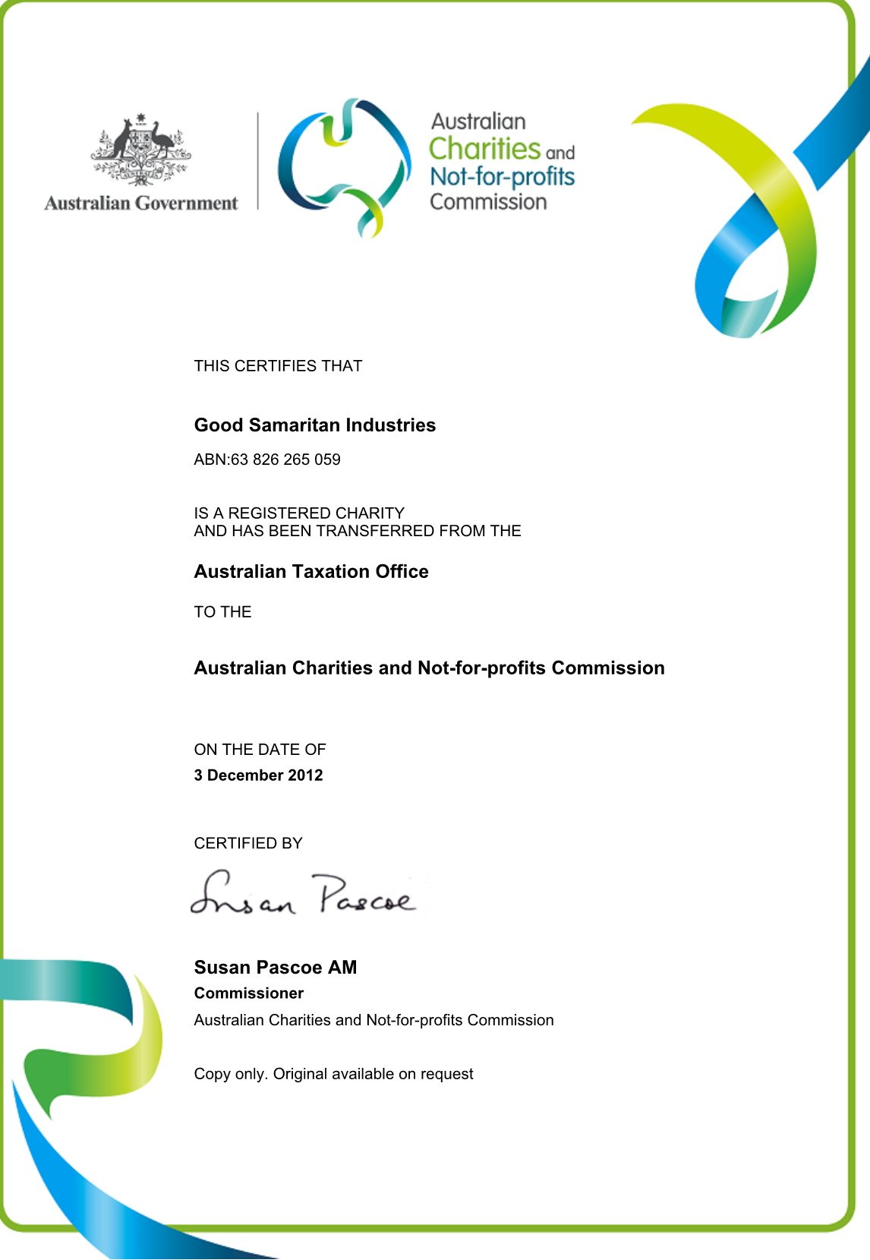
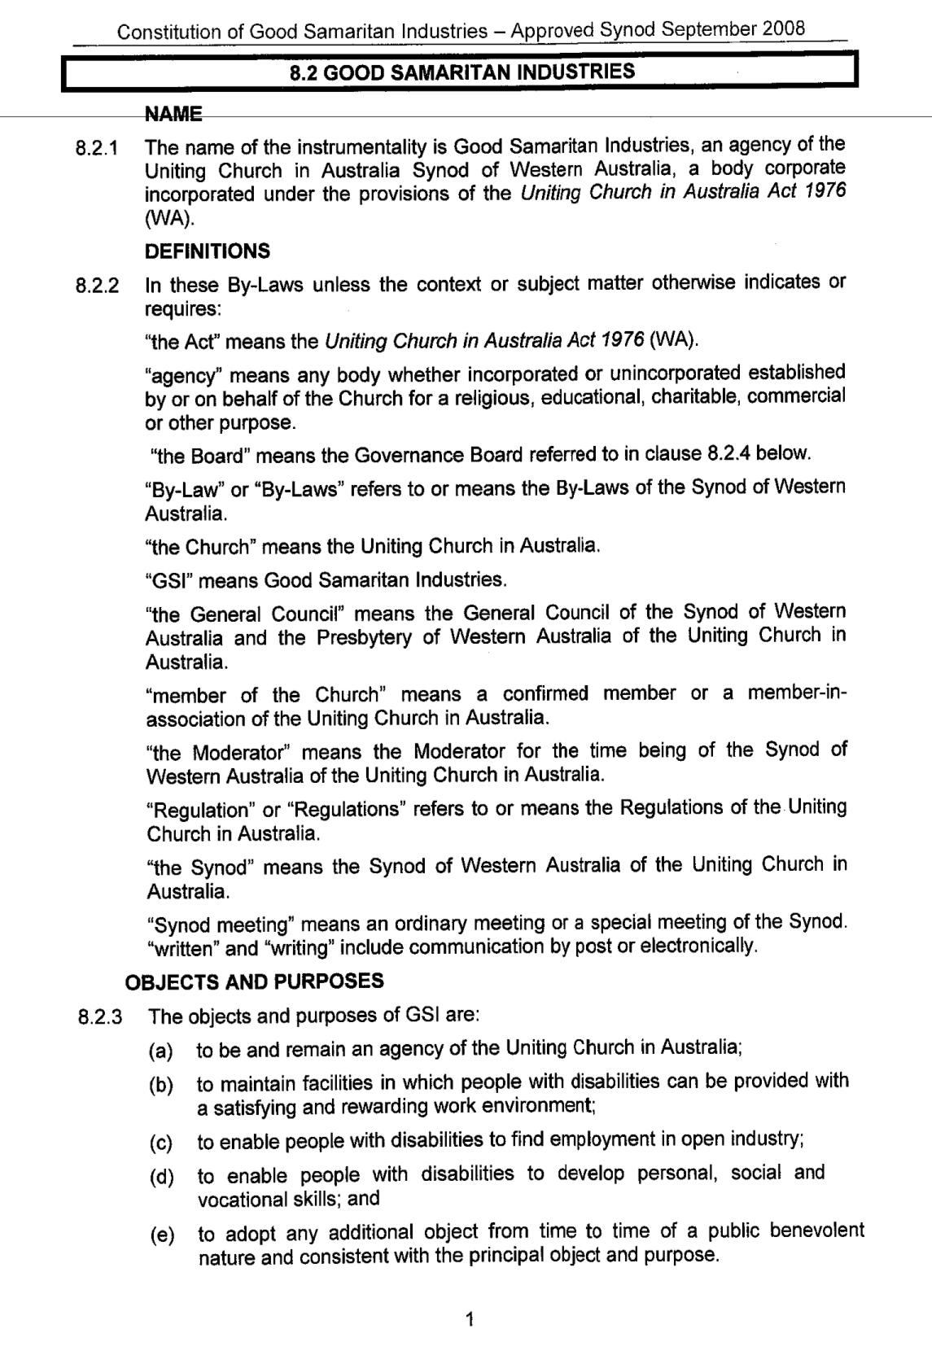
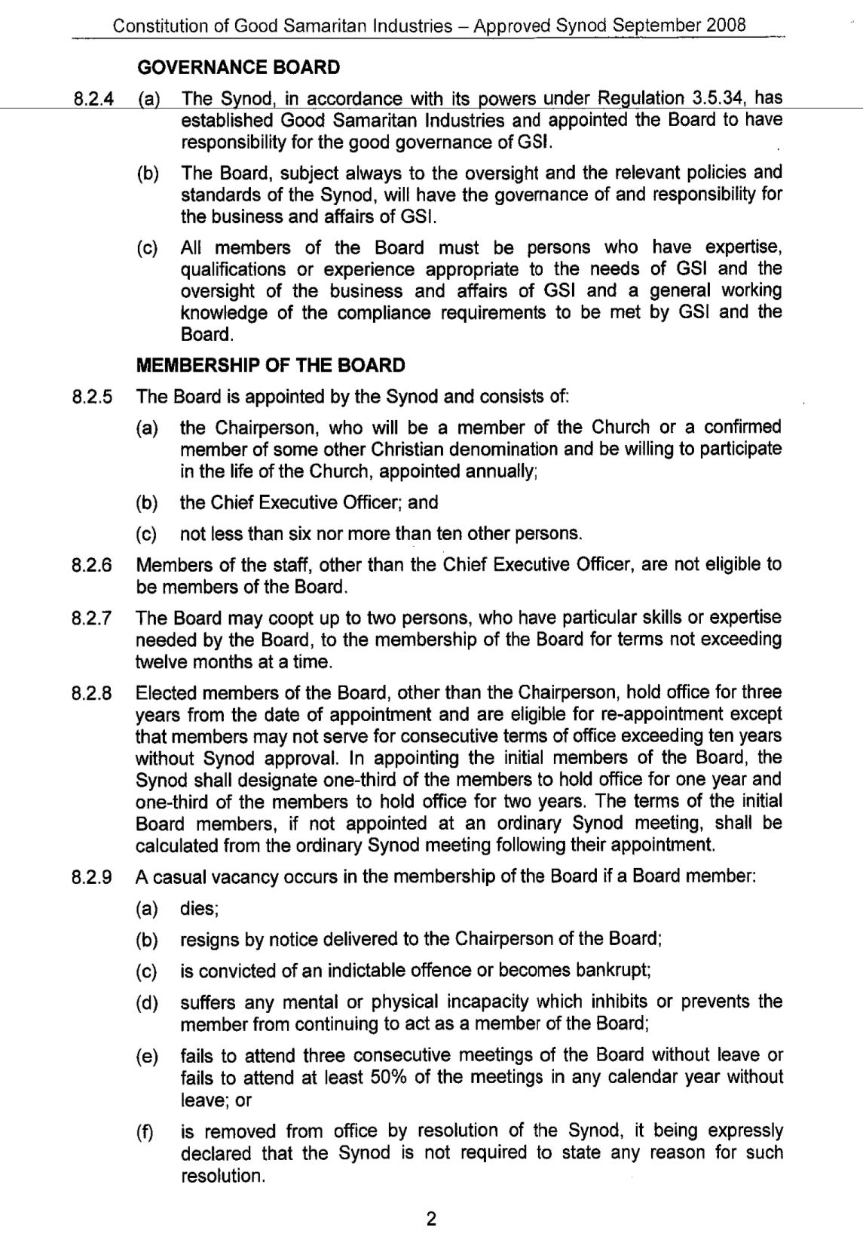
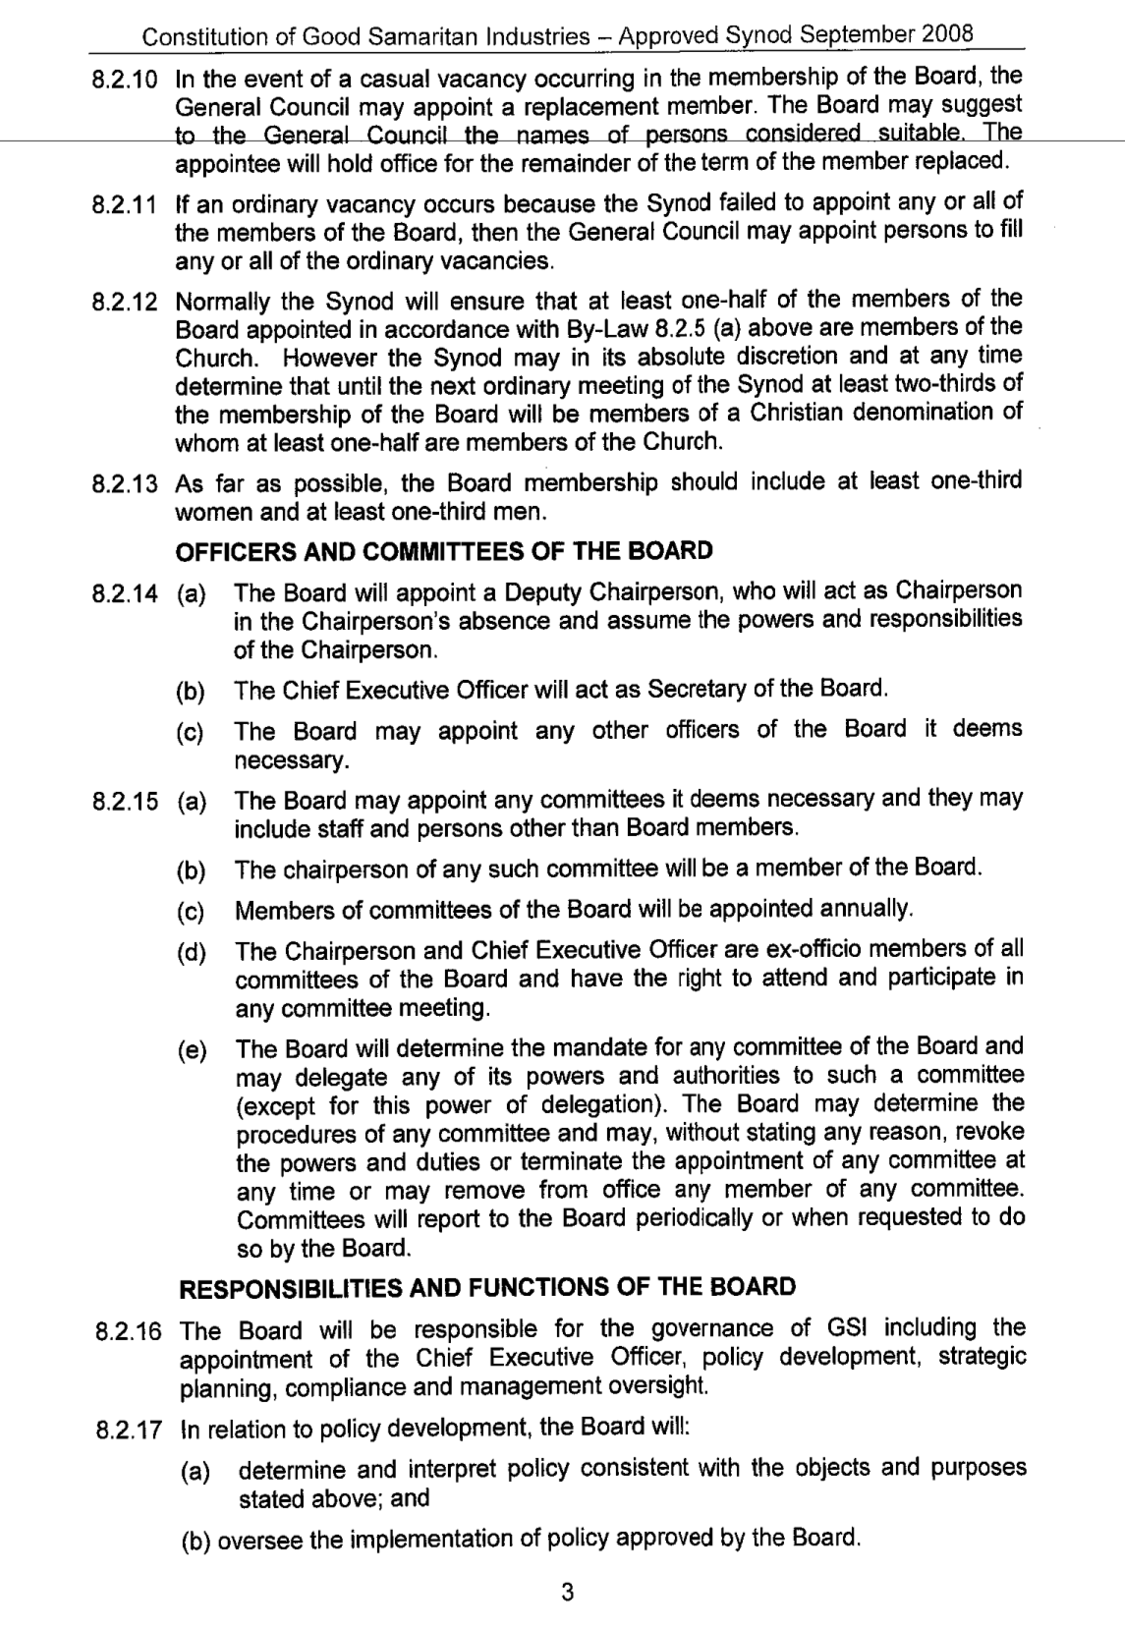
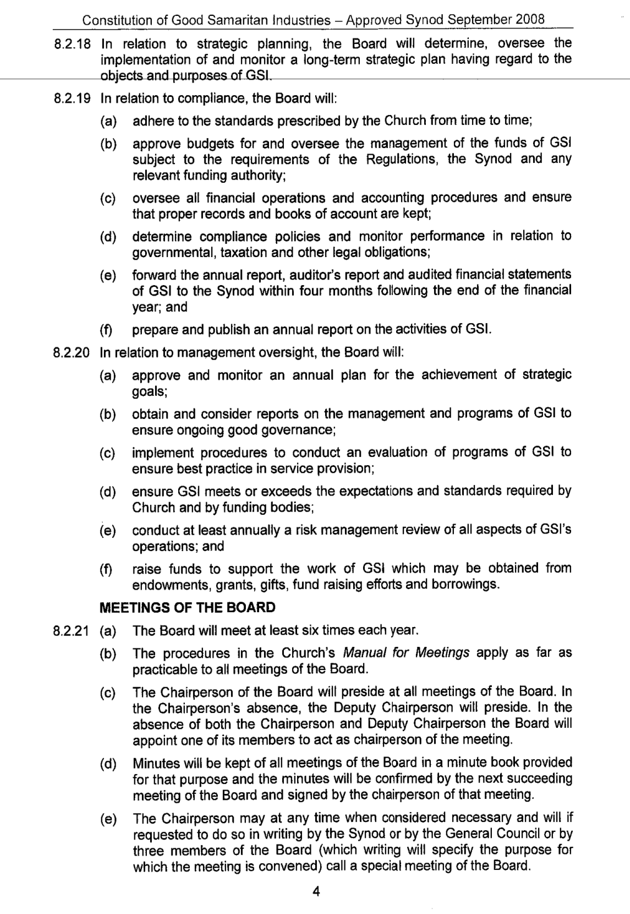
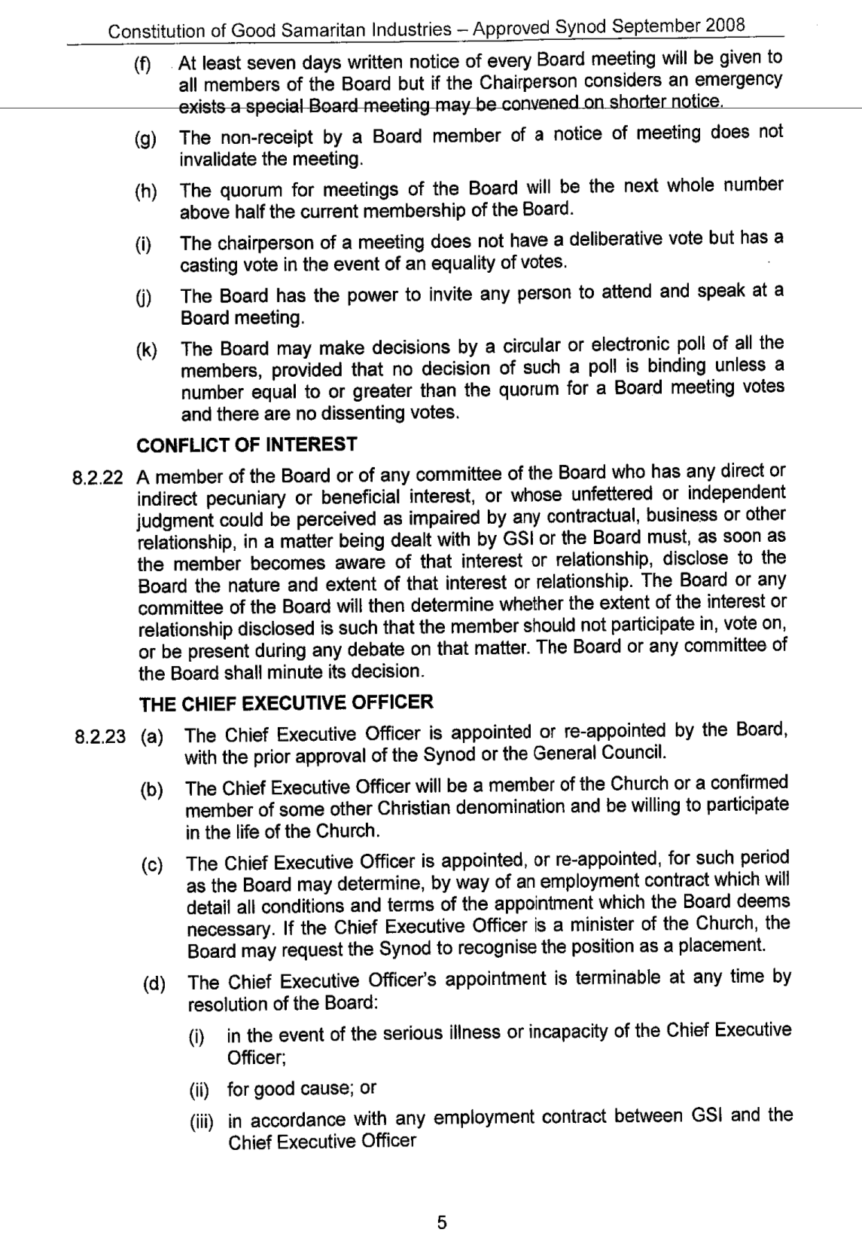
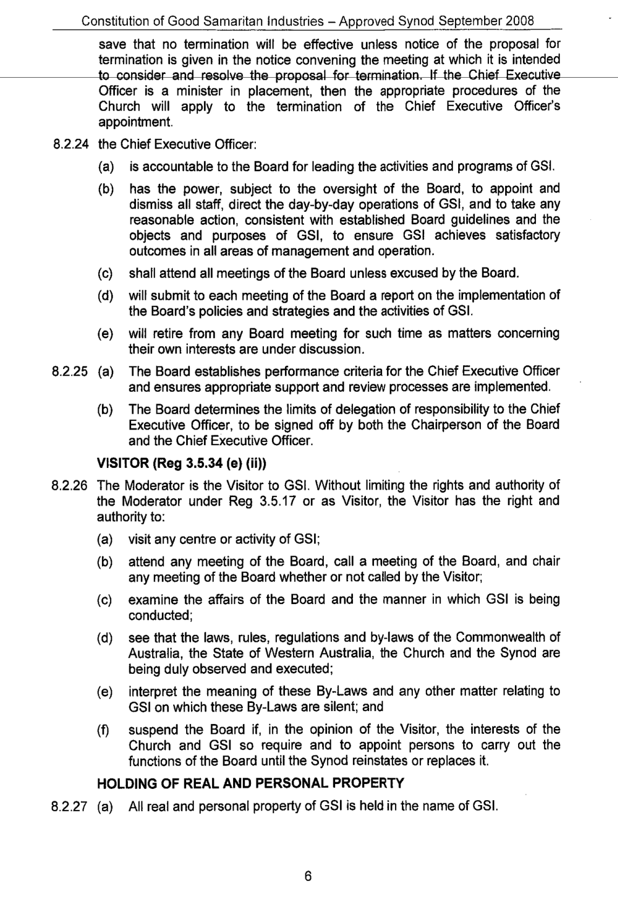
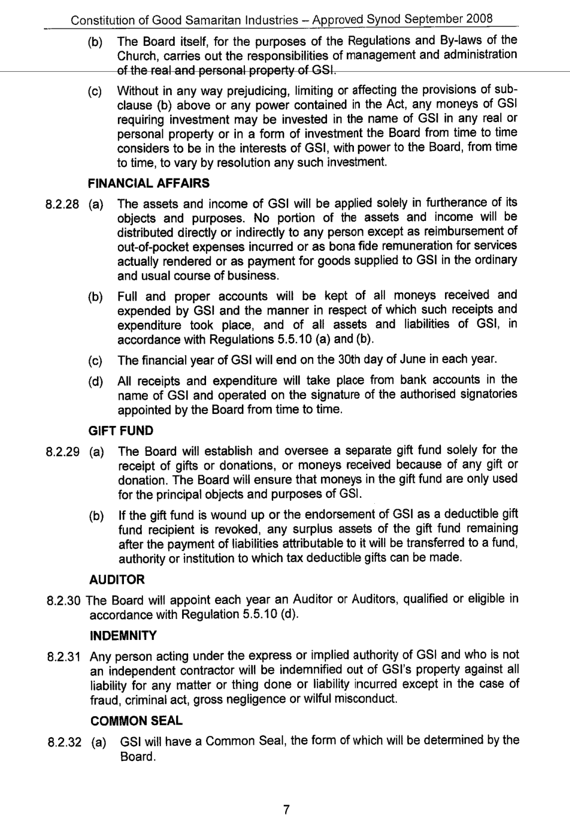
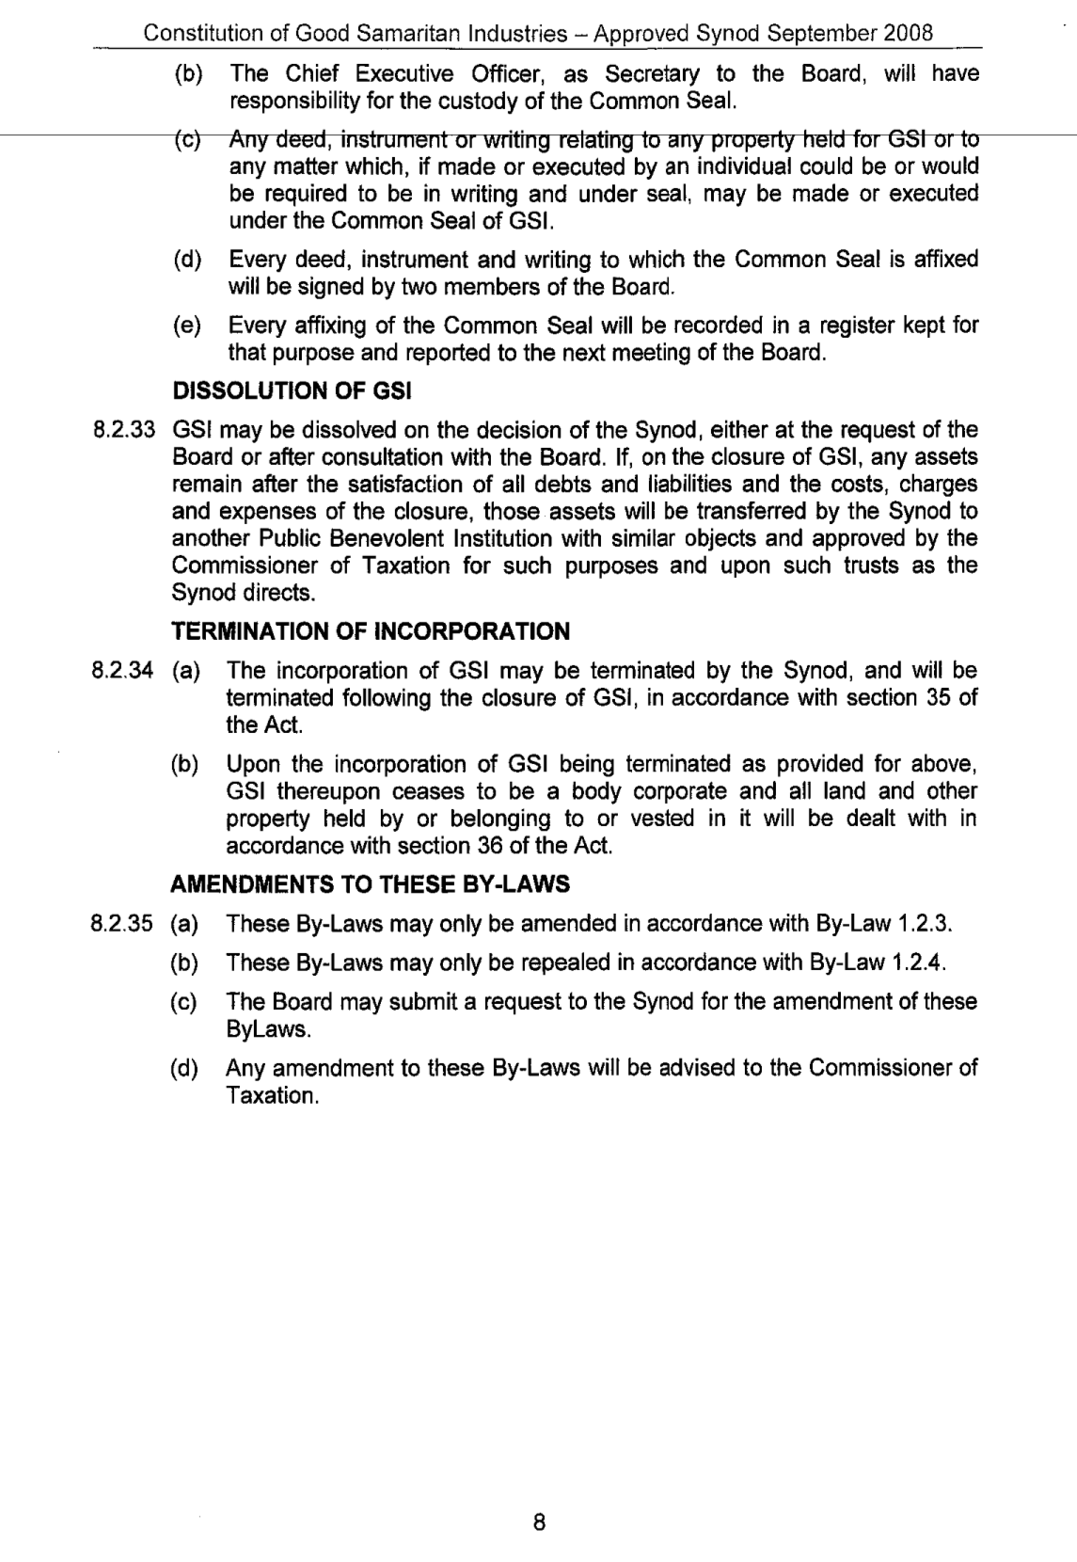

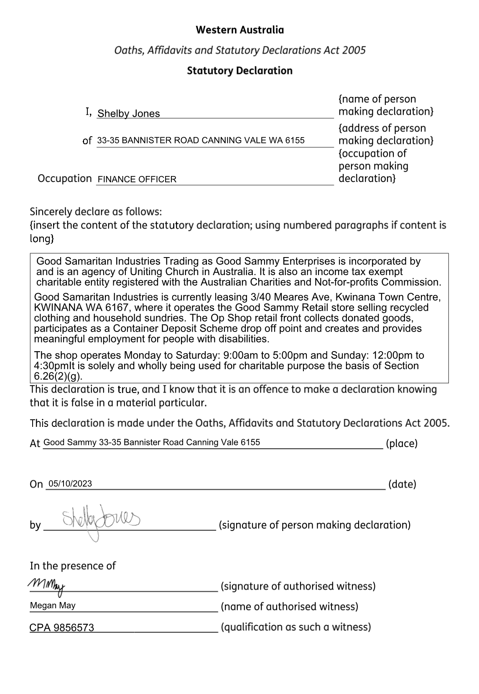
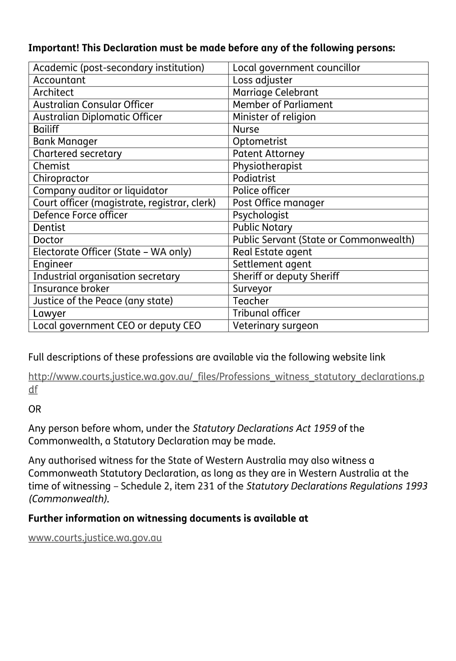

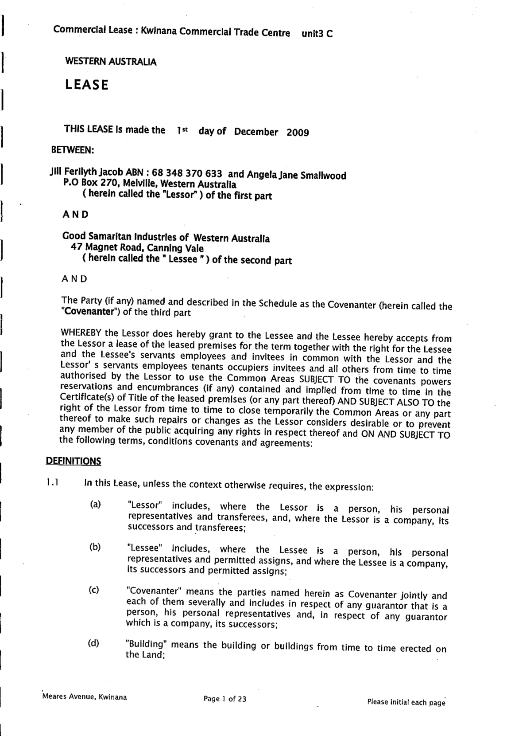
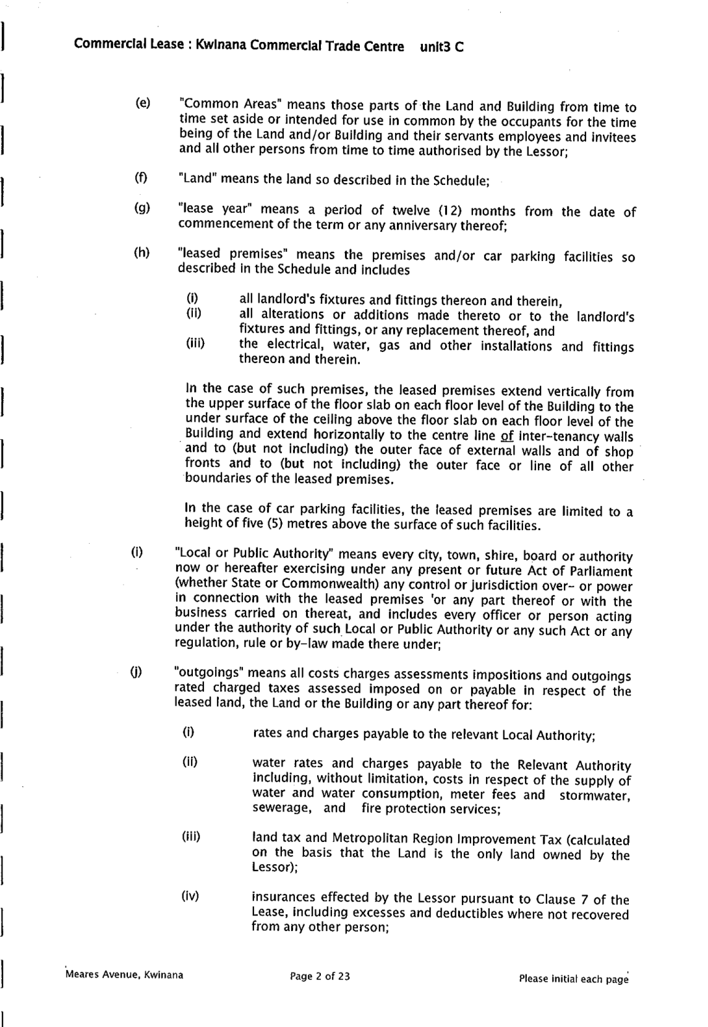
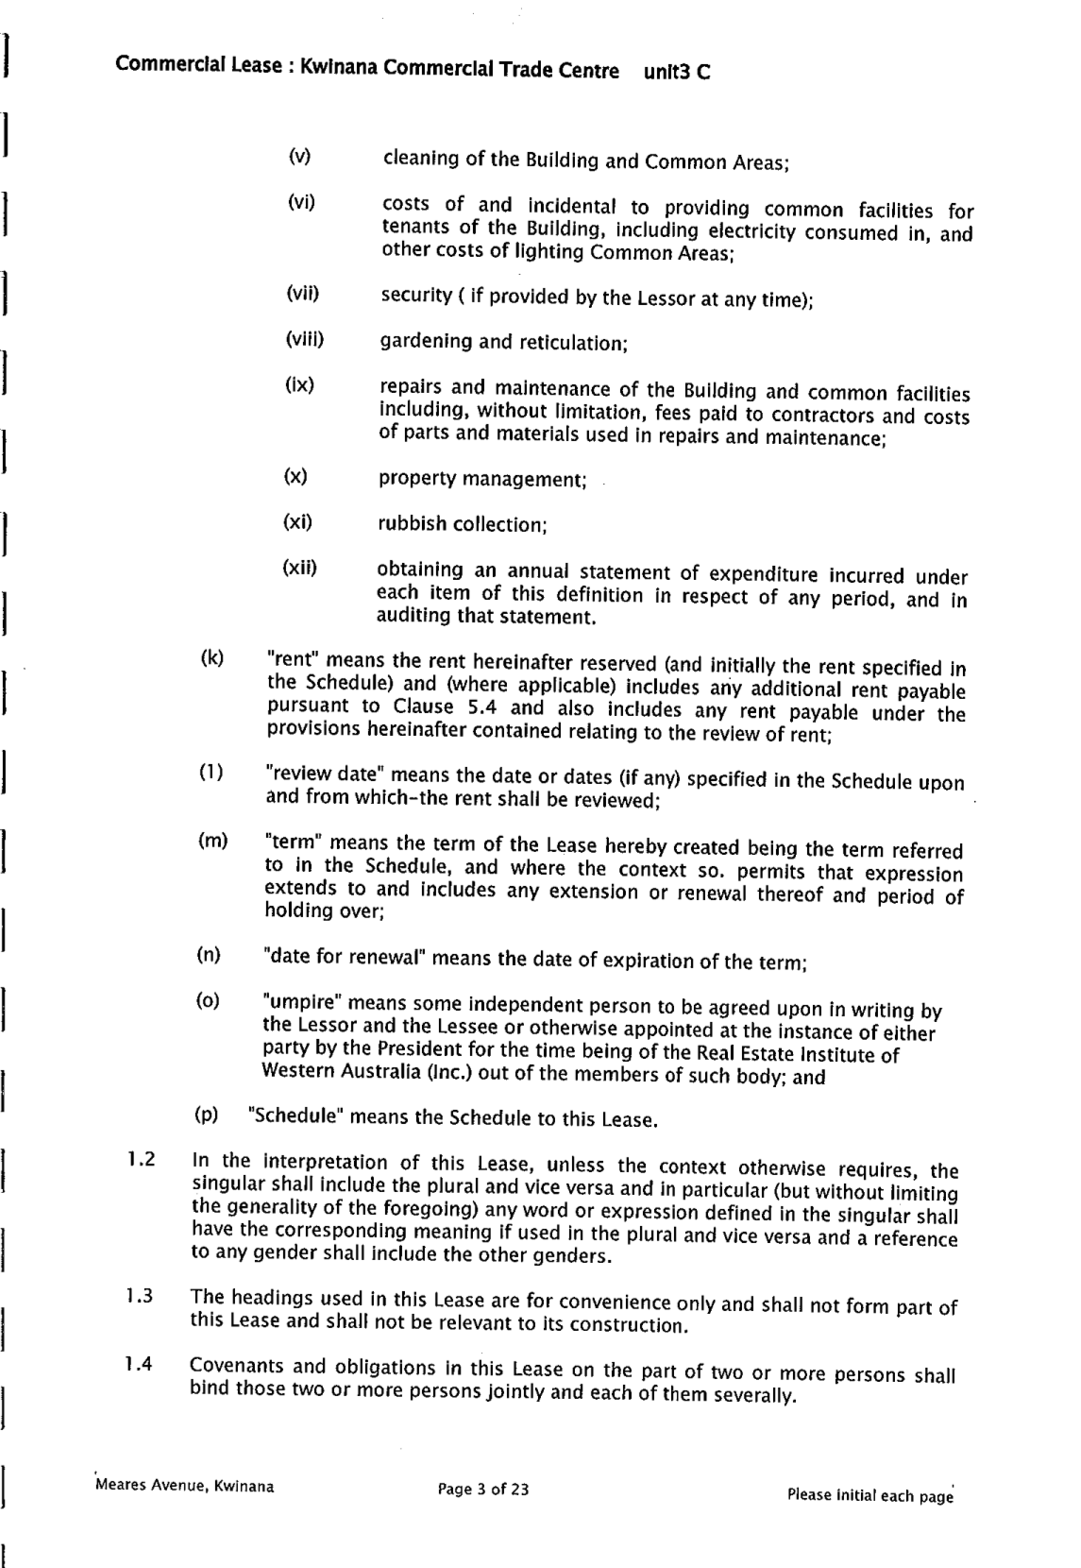
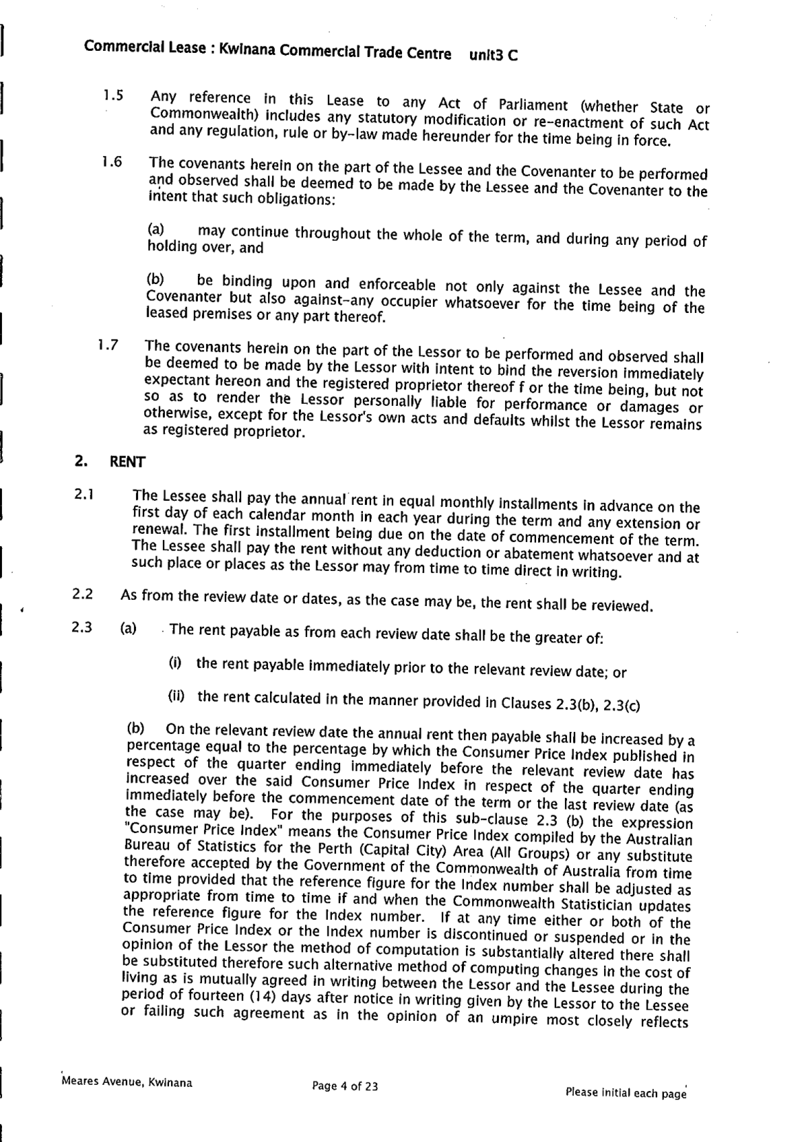
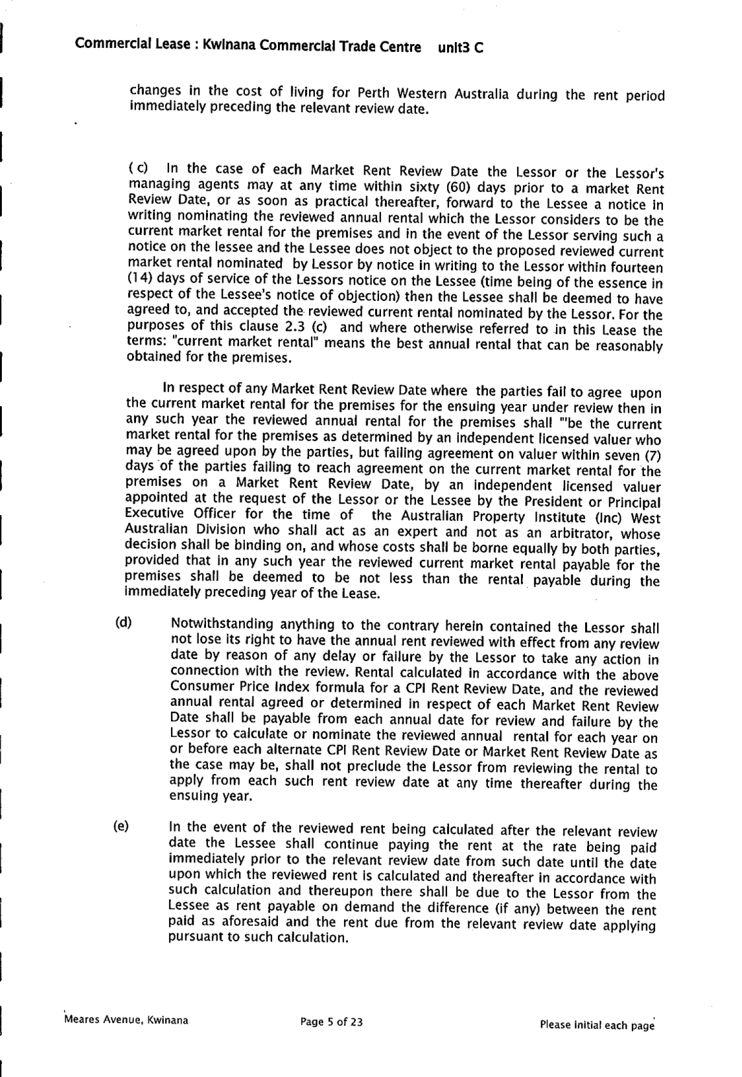
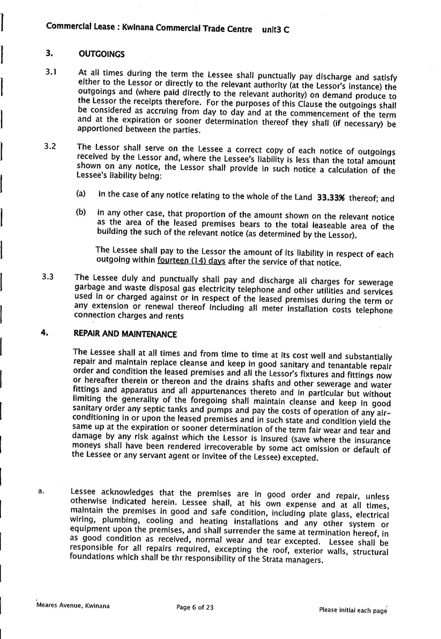
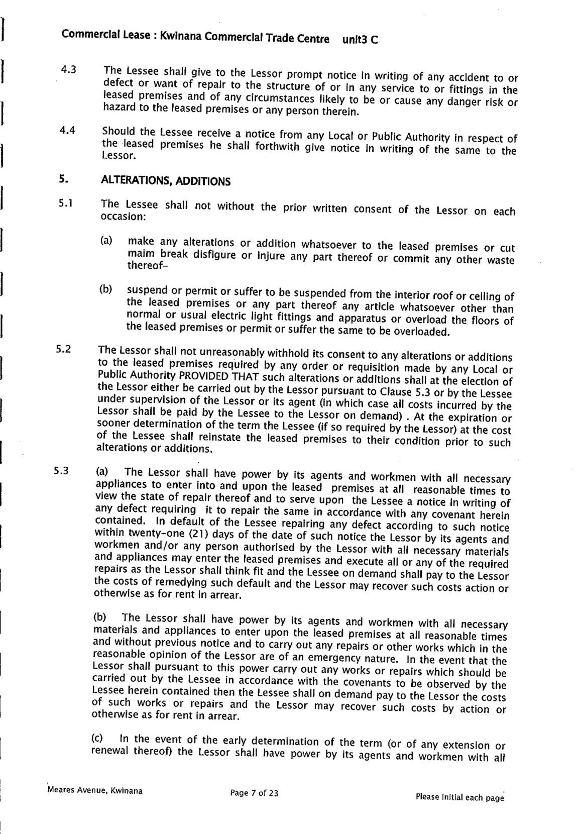
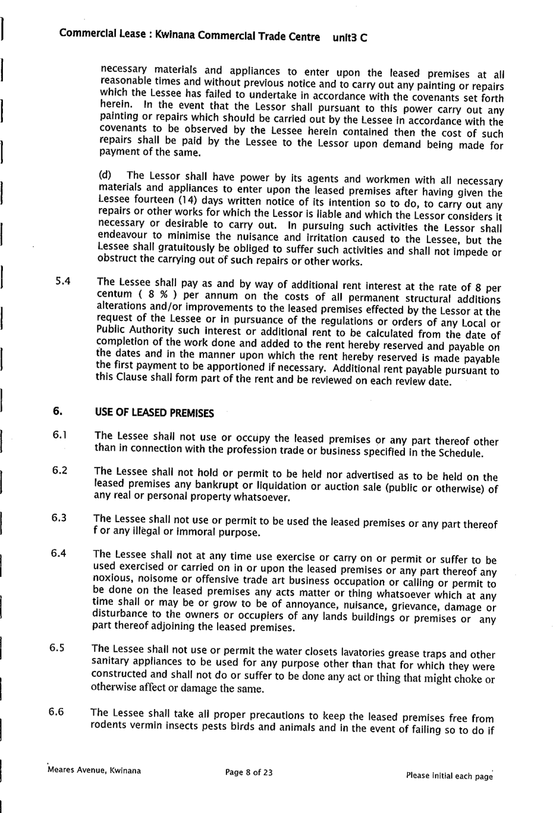
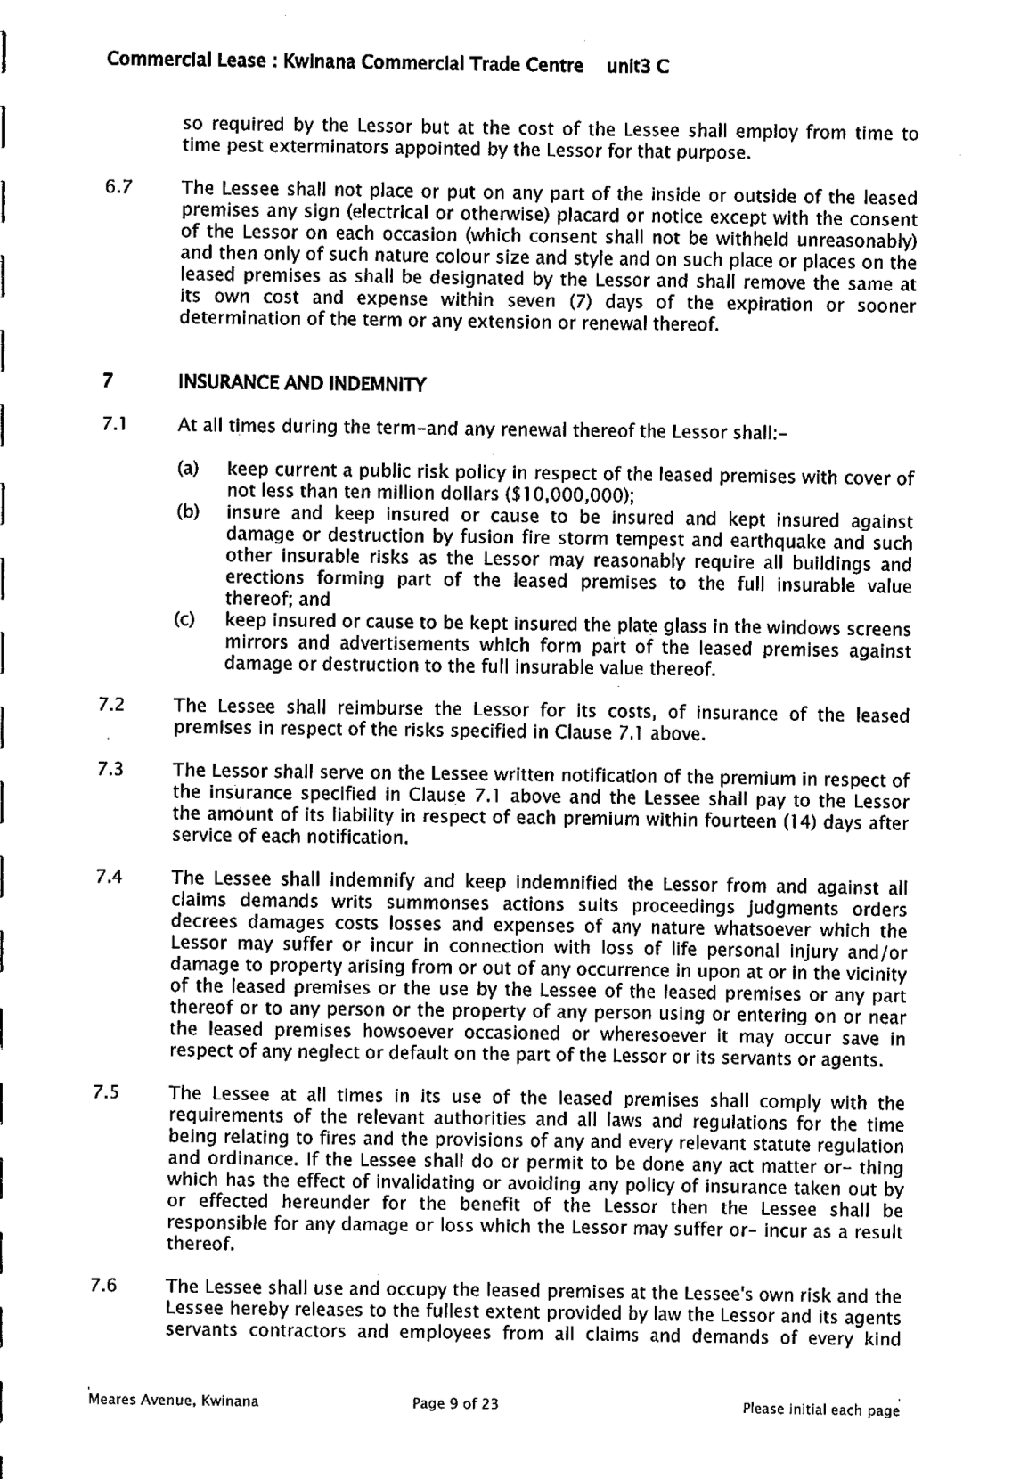
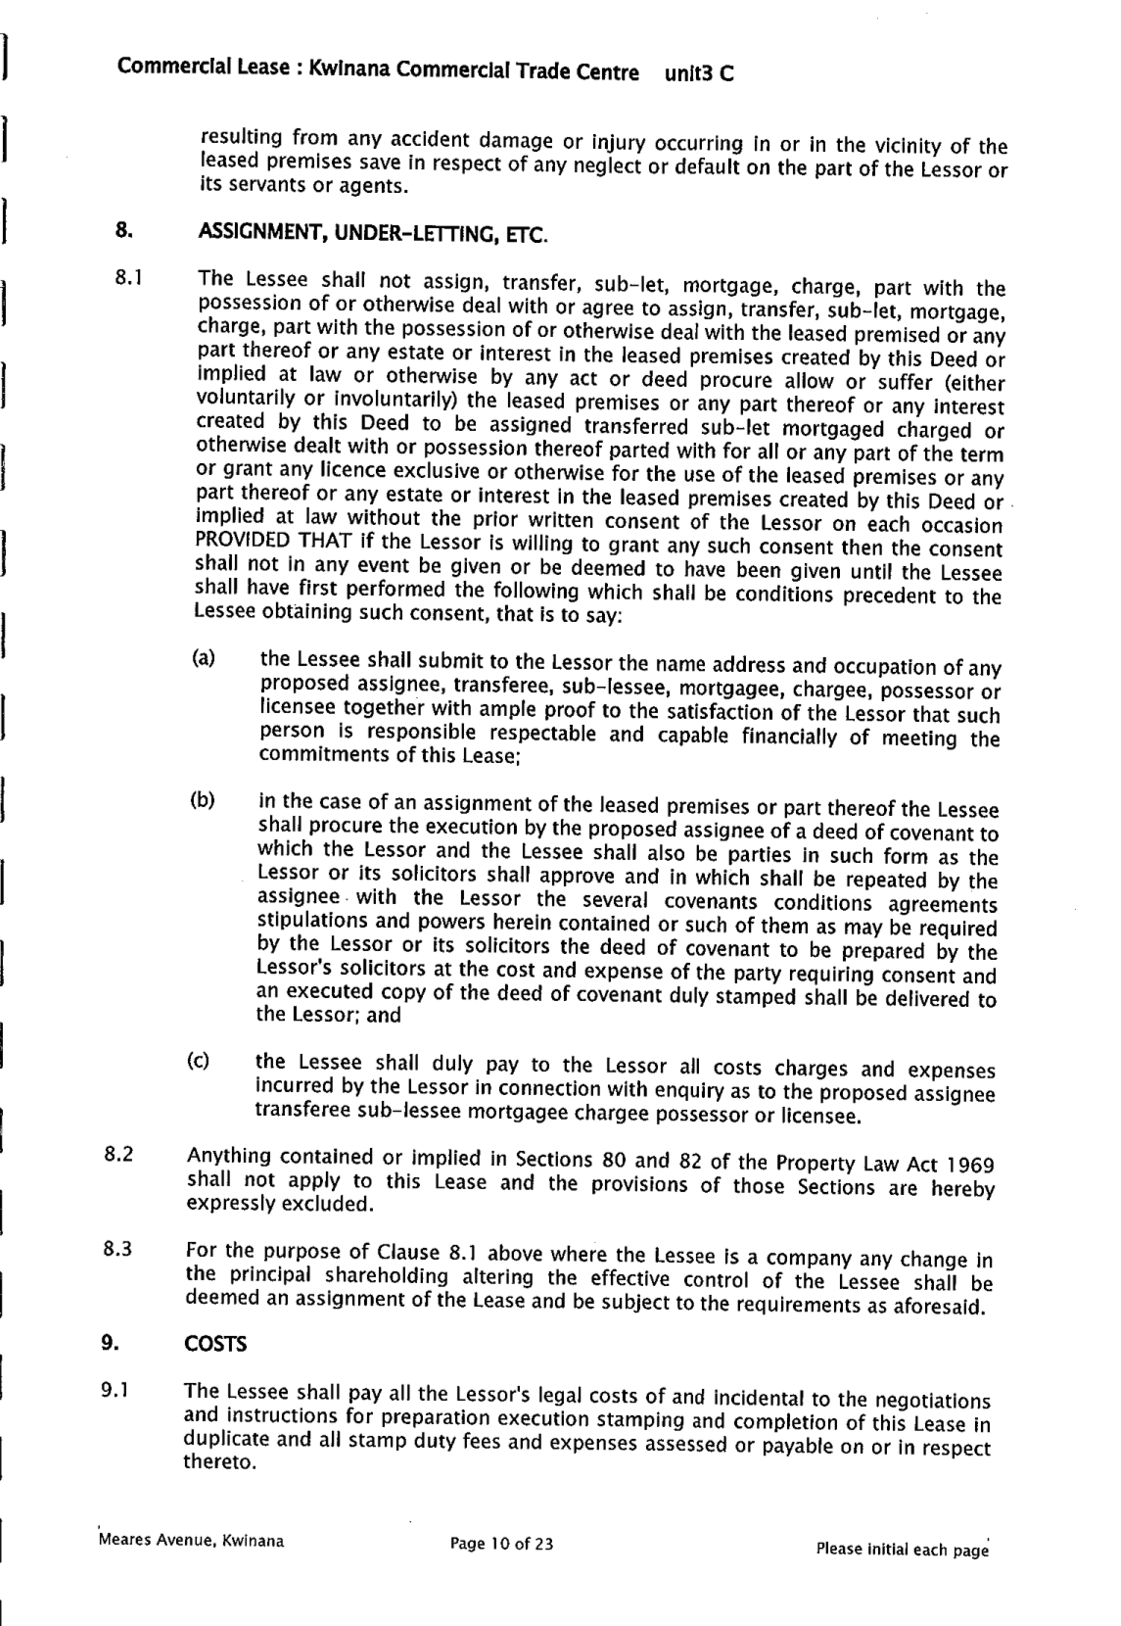
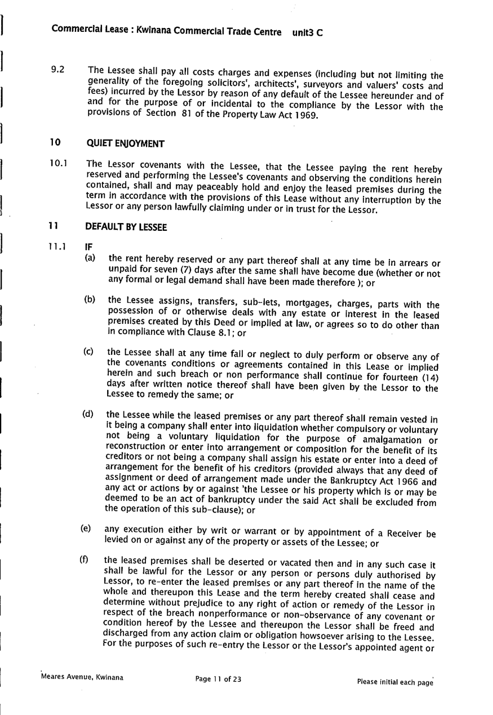
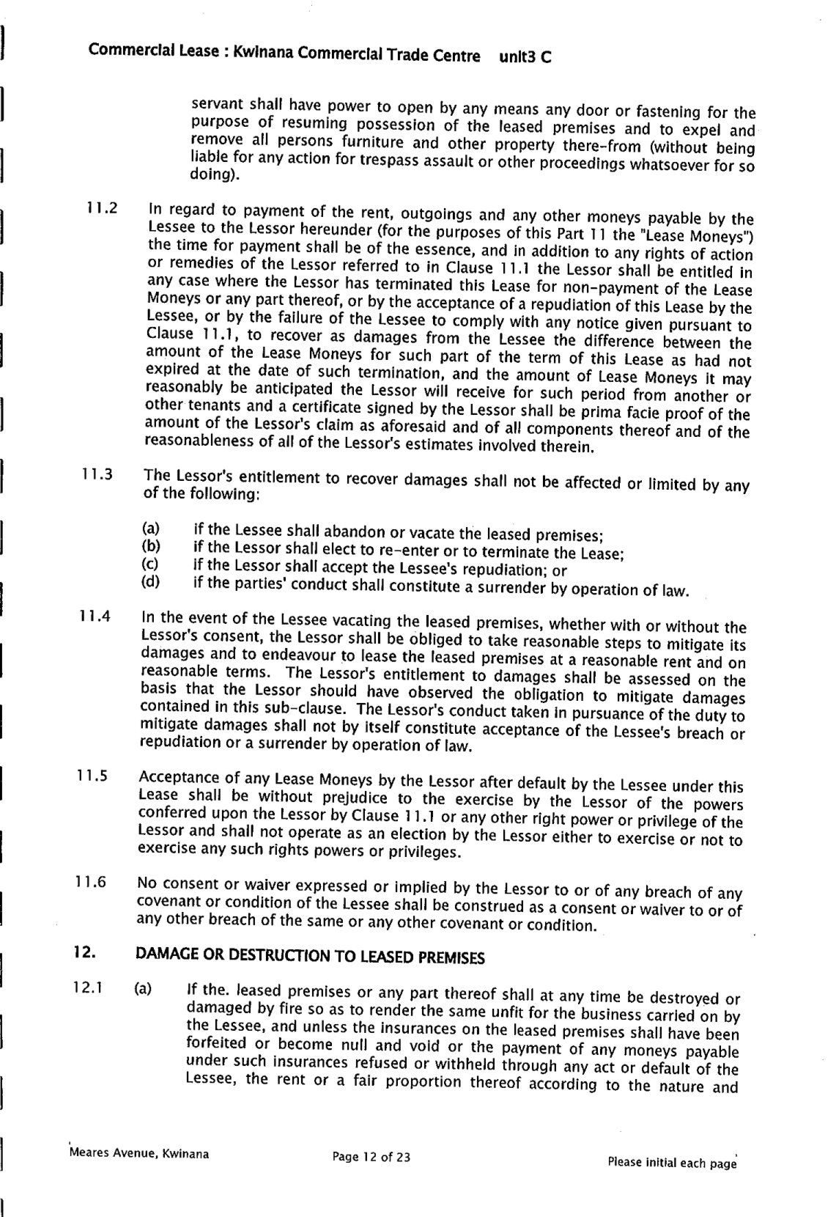

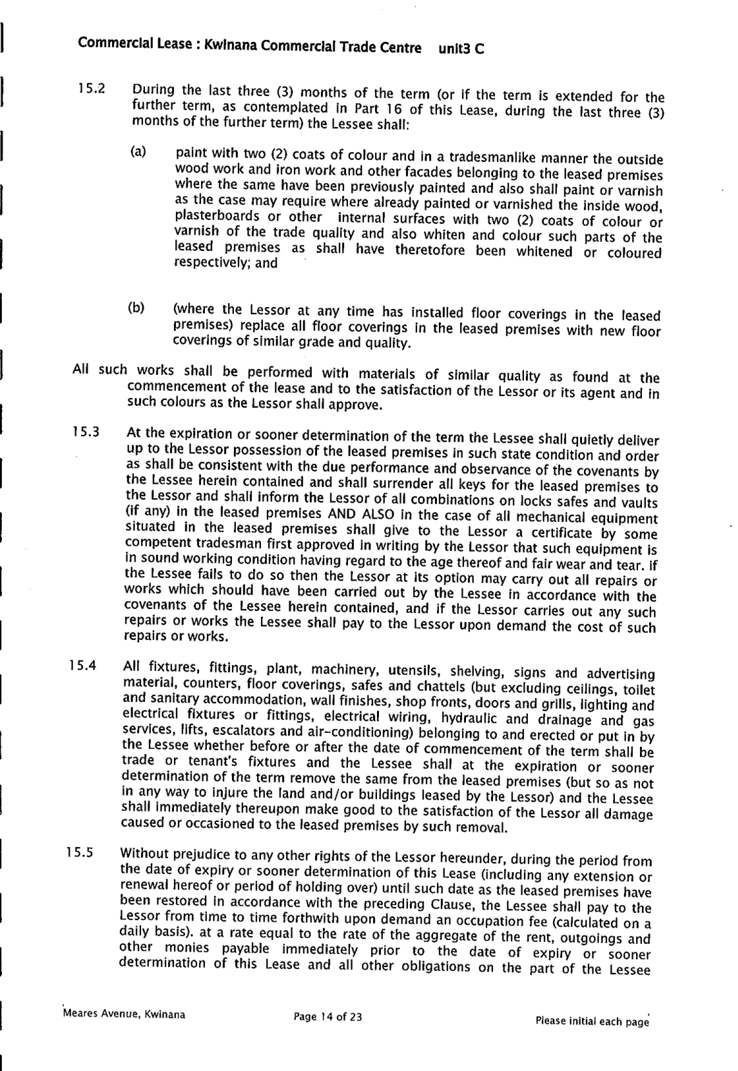
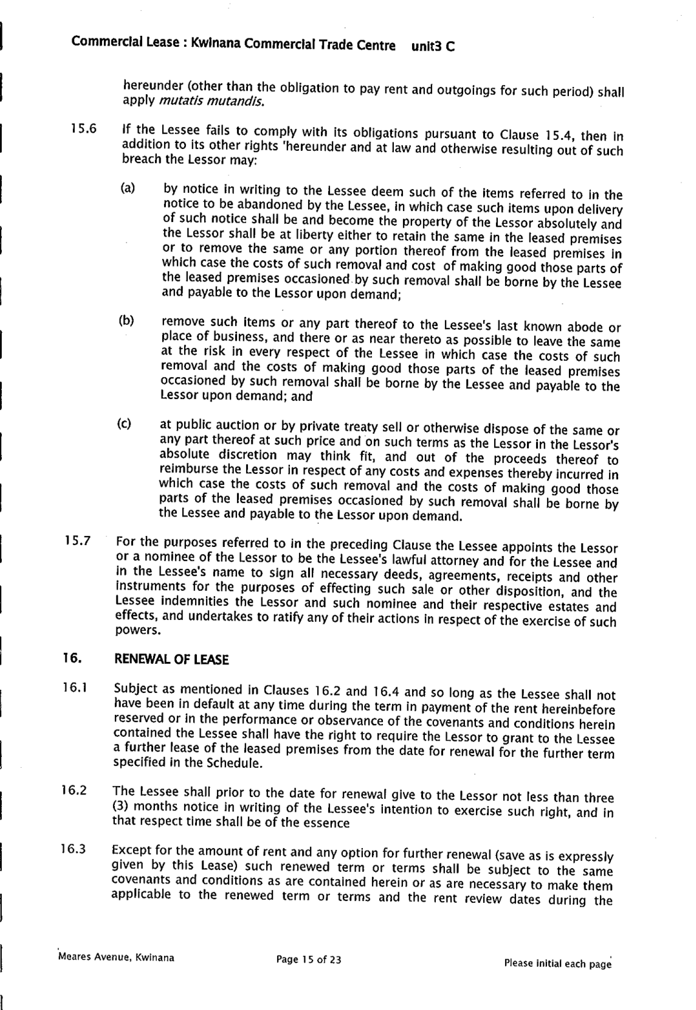
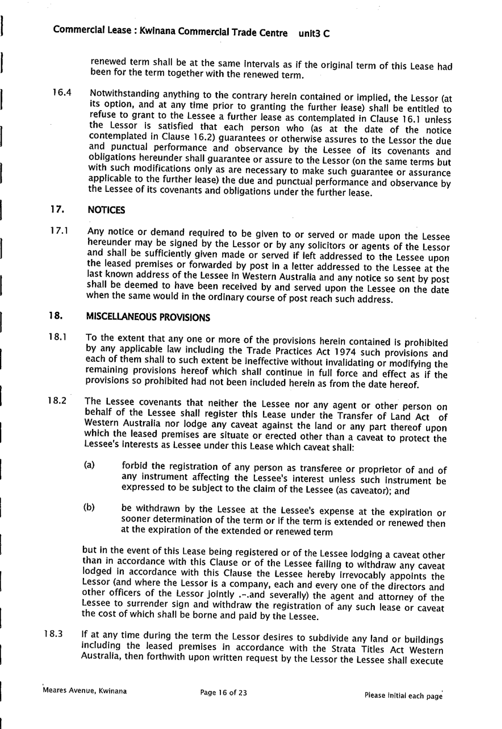
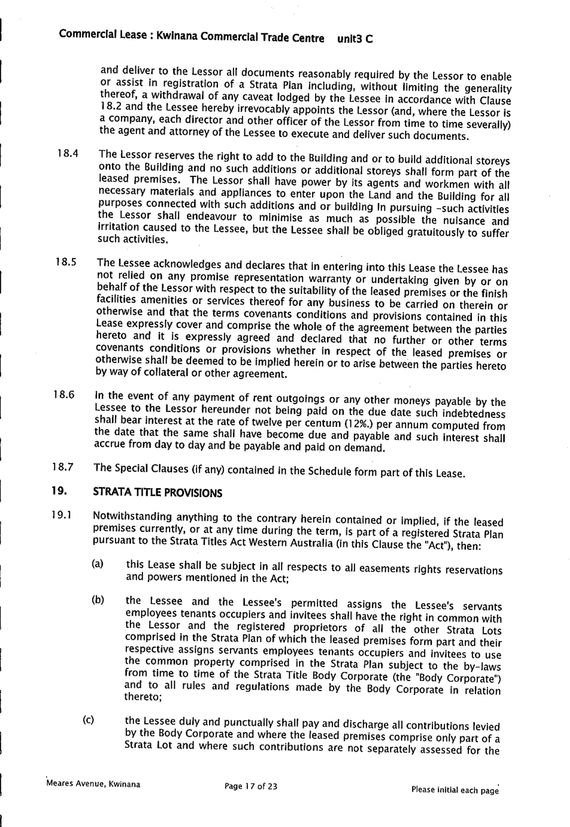
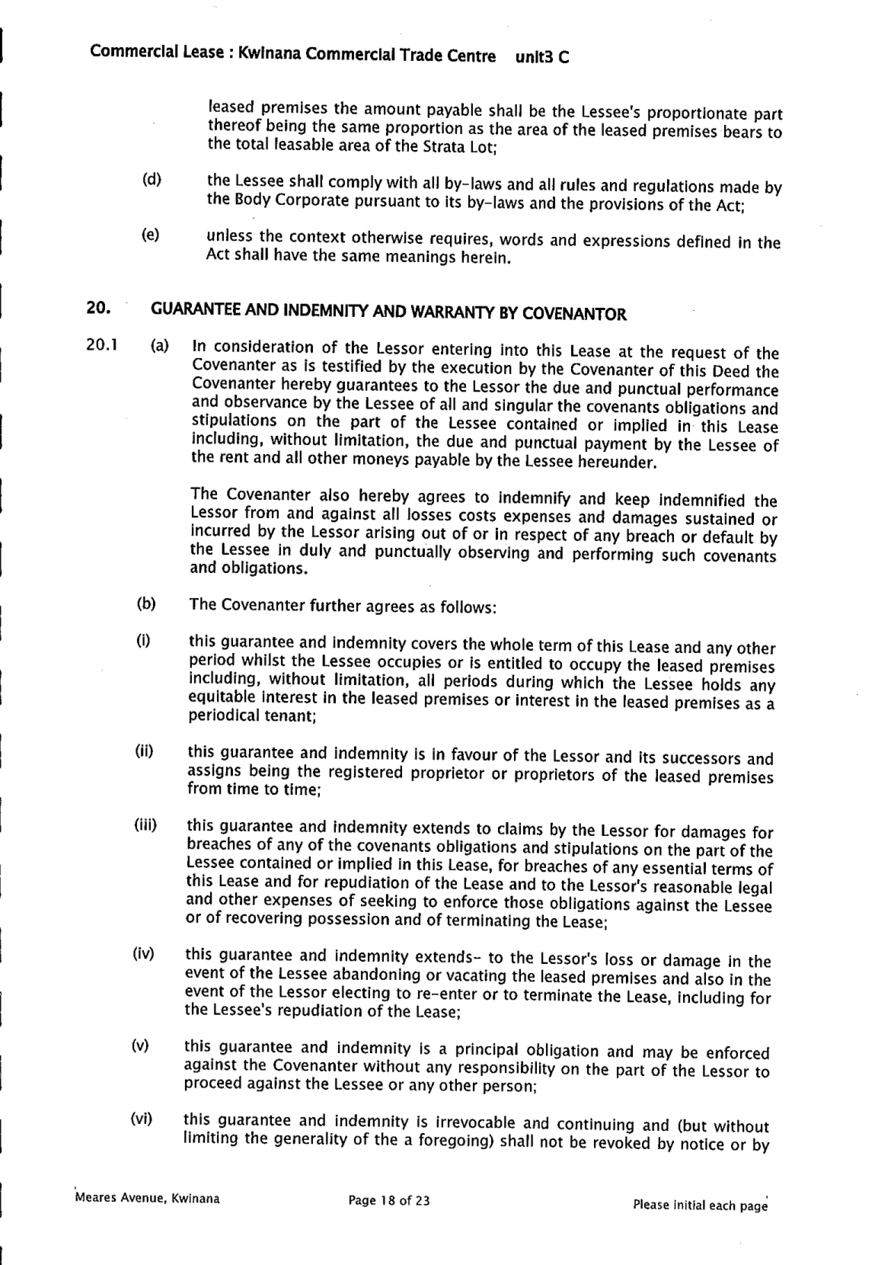
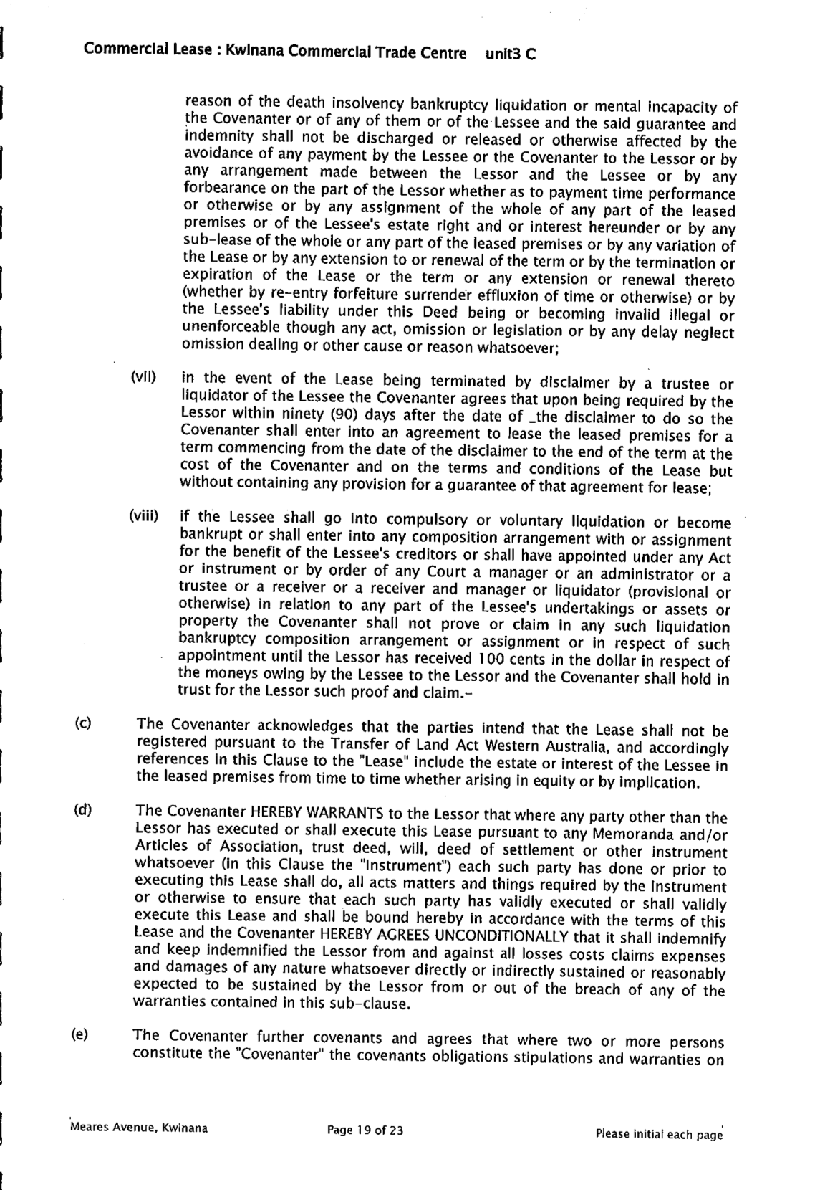

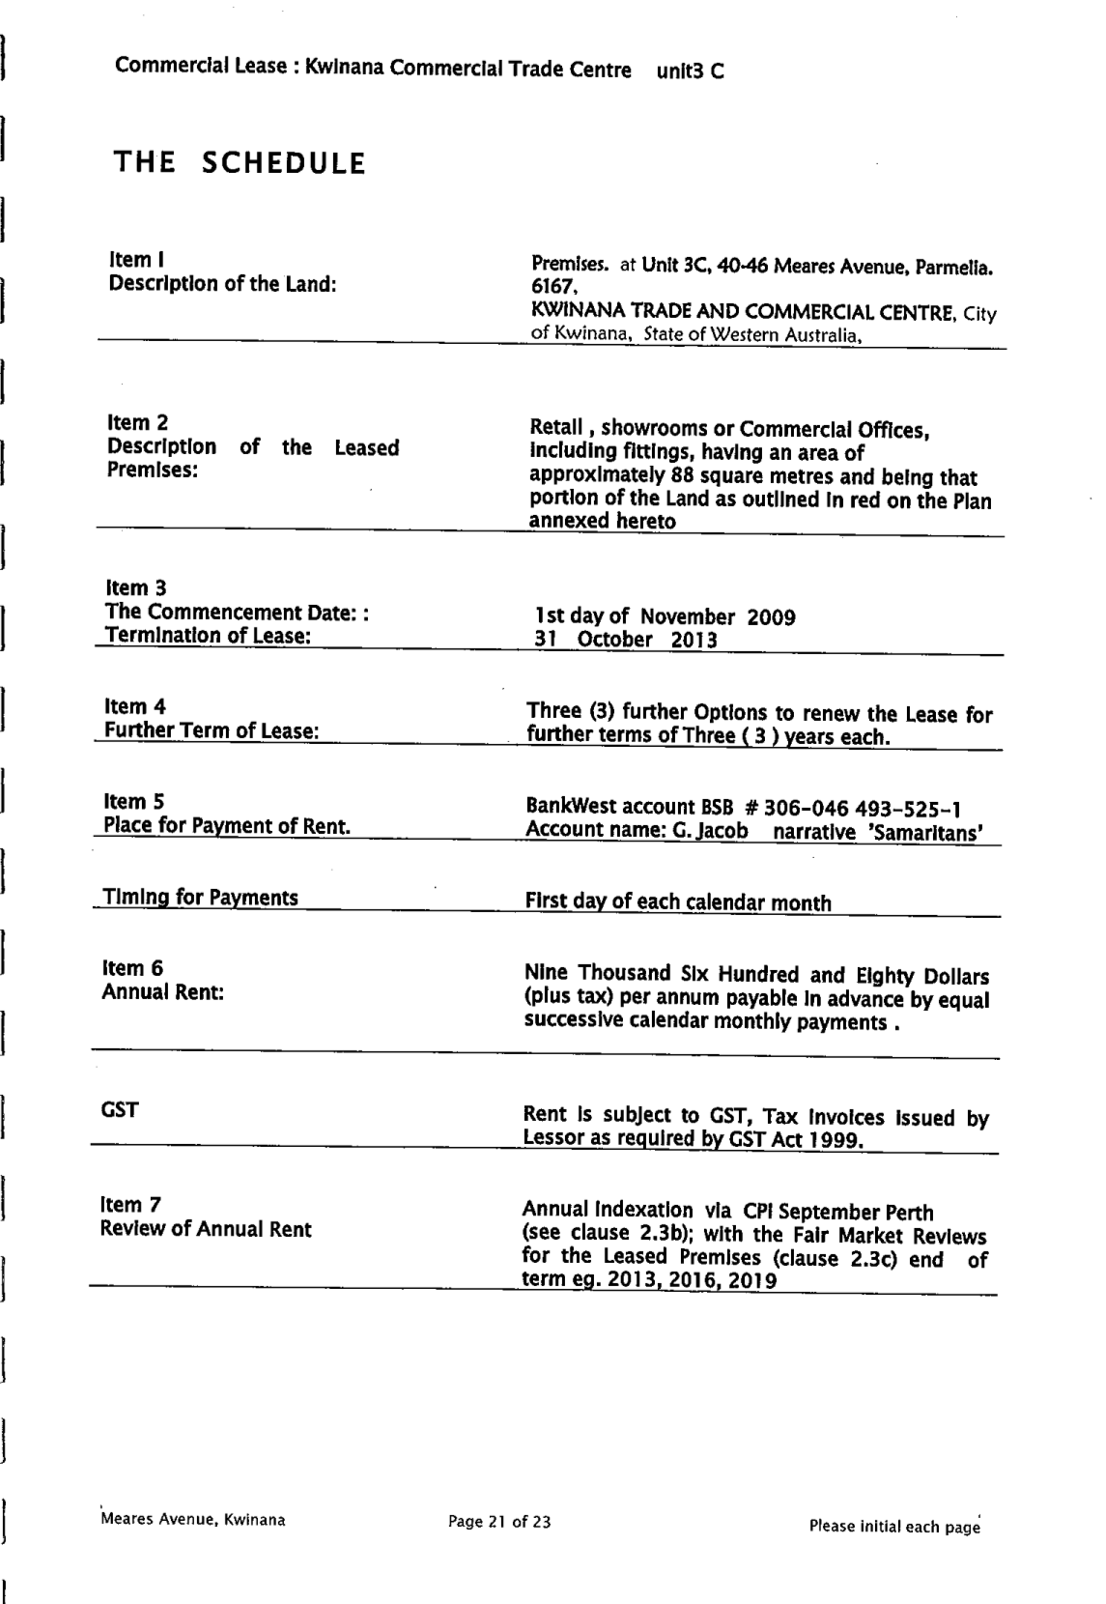
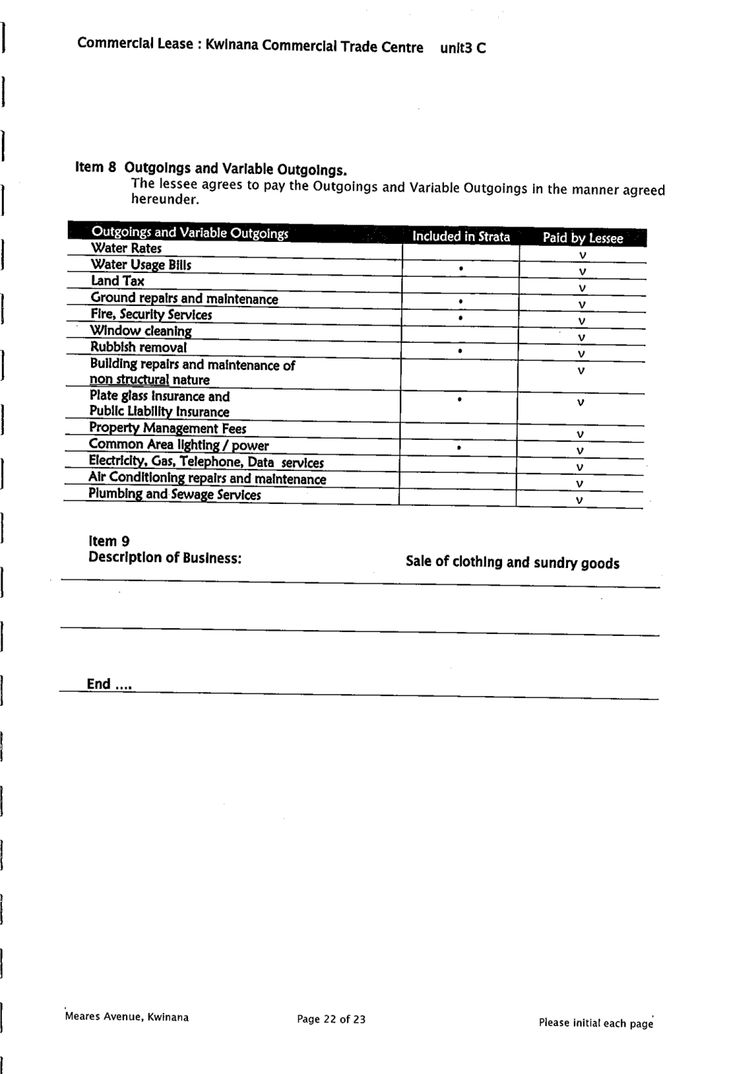
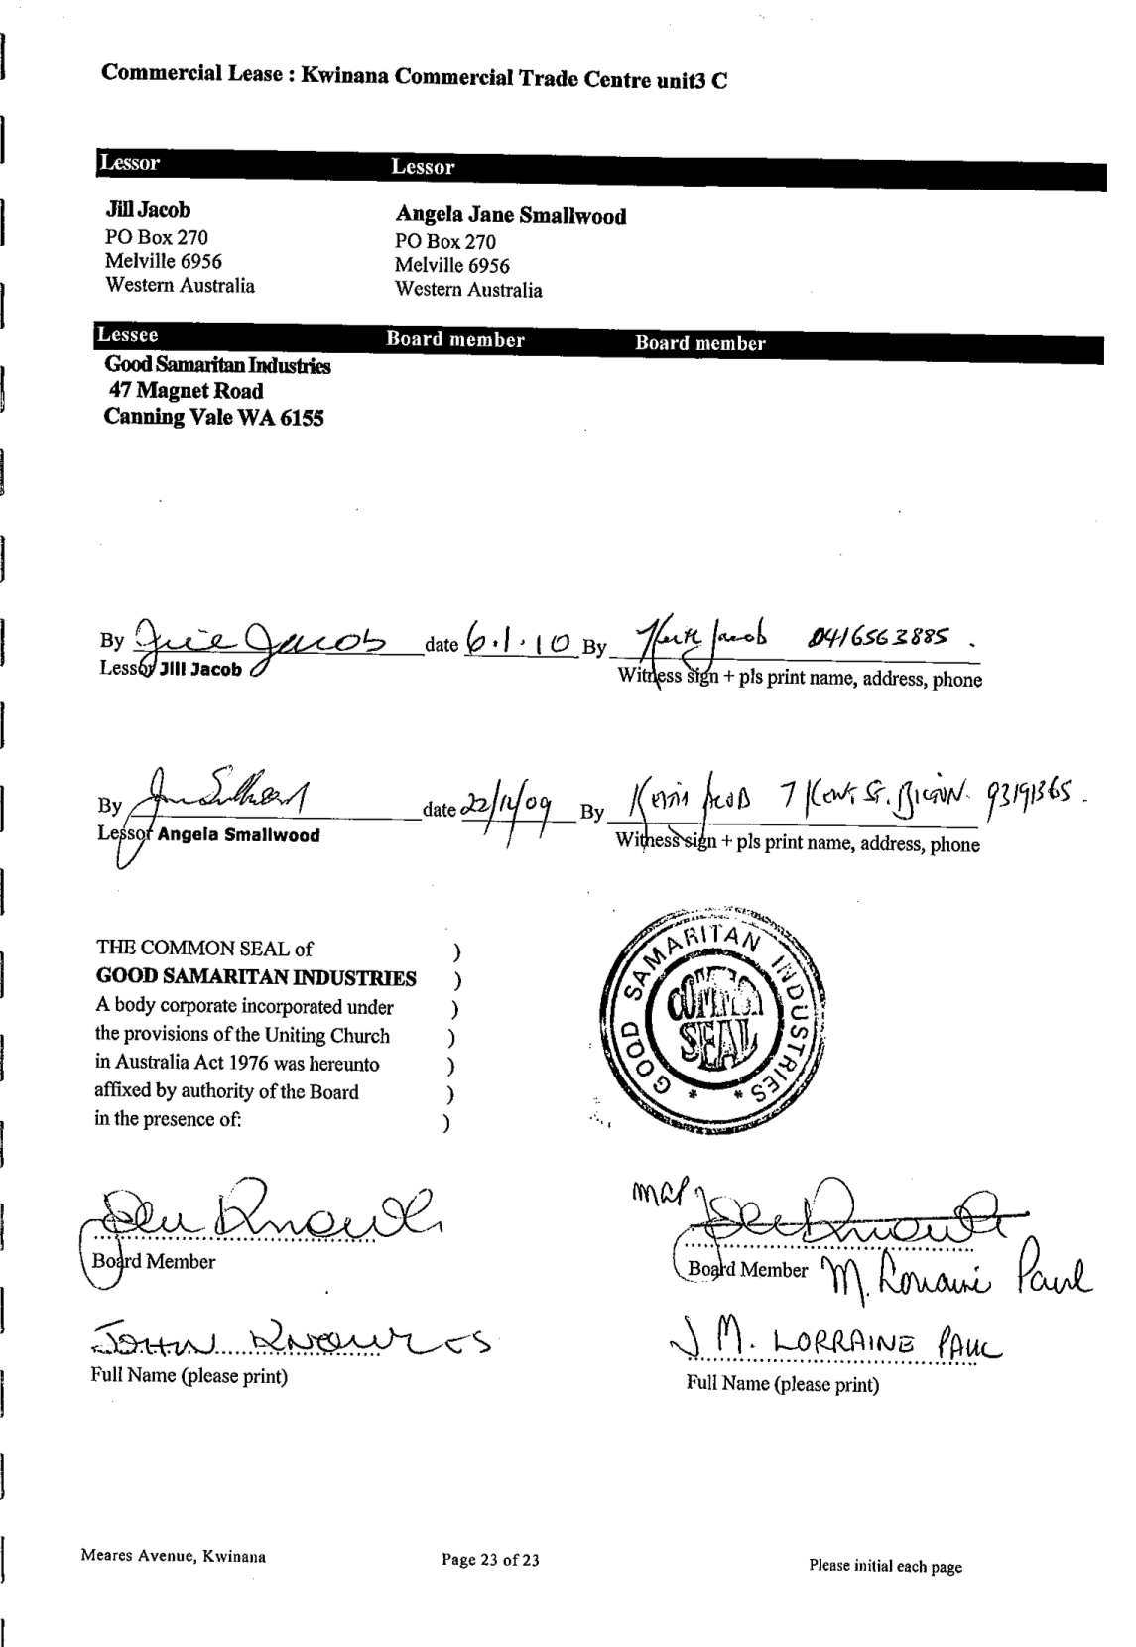
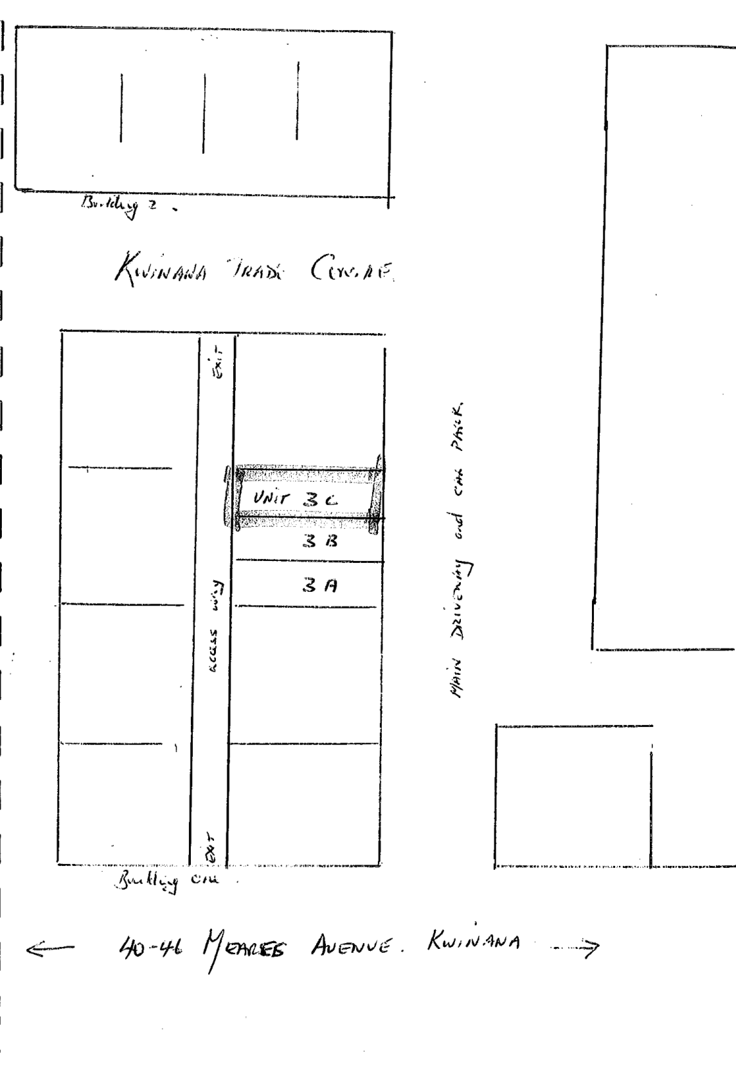

15.2 Locality Change Request - Lot 9082 Runnymede Gate, Leda - Stage 49 The Village at Wellard

Summary

Taylor Burrell Barnett (TBB) act for the Wellard Joint Venture (WJV) comprised of Peet Limited (Peet) and the Department of Communities (DoC).

As part of WJVs sub-division for Stage 49 of The Village, the City of Kwinana (City) has been requested by TBB to initiate a locality change of the area such that it forms part of neighbouring Wellard. The request impacts the following parcels:

• Lot 9082 Runnymede Gate, Leda; and
• Reserve 40166.

A copy of the request from TBB is provided at Attachment A and details the basis for the proposed change, namely:

• The subject site is physically disconnected from the Leda locality by a railway reserve to the north. In accordance with the approved Wellard Village Structure Plan, the subject site can only be accessed via a vehicle overpass along Lambeth Circle, within the Wellard road network.
• Noting the subject site can only be accessed via the Wellard locality road network, emergency services may have difficulty locating and accessing the site if it remains listed within the Leda locality.
• The proposal will ensure the address of the residential lots will be consistent with the remainder of The Village at Wellard and provide a connection to the surrounding local community.
• The residential lots approved under WAPC Ref. 163248 are yet to be created. This presents an opportunity to amend the locality boundary prior to the scheduled titling of the lots in July 2024, and prior to street addresses being finalised.

Subject to Councils endorsement, Landgate have expressed their in-principle support of the proposed locality change. This is on the basis that emergency services may be delayed in accessing the area should they not be aware it forms a disconnected pocket from the remainder of Leda (by virtue of the dissecting train line).

Landgate’s recommendation is that the new Lot 8001, which will form public open space, would be best aligned with Reserve 33581 (to the west) and therefore continue to remain within Leda. This is not supported by the City on the basis that the majority of users will be adjoining owners from (re-classified) Wellard.

Reserve 40166 belongs to Water Corporation, with the City possessing a Management Order. They have advised the City that they have no objection to the locality change.

Officer Recommendation

That Council resolve to support a locality change of Lot 9082 and Reserve 40166 from Leda to Wellard.

Voting Requirement

Simple majority

Discussion

The role of local governments with respect to requests for locality name changes is to assess proposals and support only when it is in line with relevant naming policy requirements and a compelling need for change is substantiated.

Should Council support the proposed locality change, the matter will be submitted to Landgate who are responsible for issuing approval. They may refer the matter to the Geographic Names Committee for advice where the change is potentially contentious or significant.

As all official names are meant to be enduring, any proposals to change the name of a feature, administrative boundary or road must include evidence of a compelling reason for such a change.

The developer, as the requesting party, is responsible for undertaking community consultation with respect to the proposed name change. However, as the area in question is currently vacant, no parties are directly impacted.

According to the Local Development Plan, 43 residential lots are intended to be created as part of Stage 49. All such lots will be accessible solely via Yately Way or Ebrington Road, Wellard. There will be no direct road or pedestrian access between the lots and the remainder of Leda.

Extract from Local Development Plan showing Stage 49 The Village at Wellard:

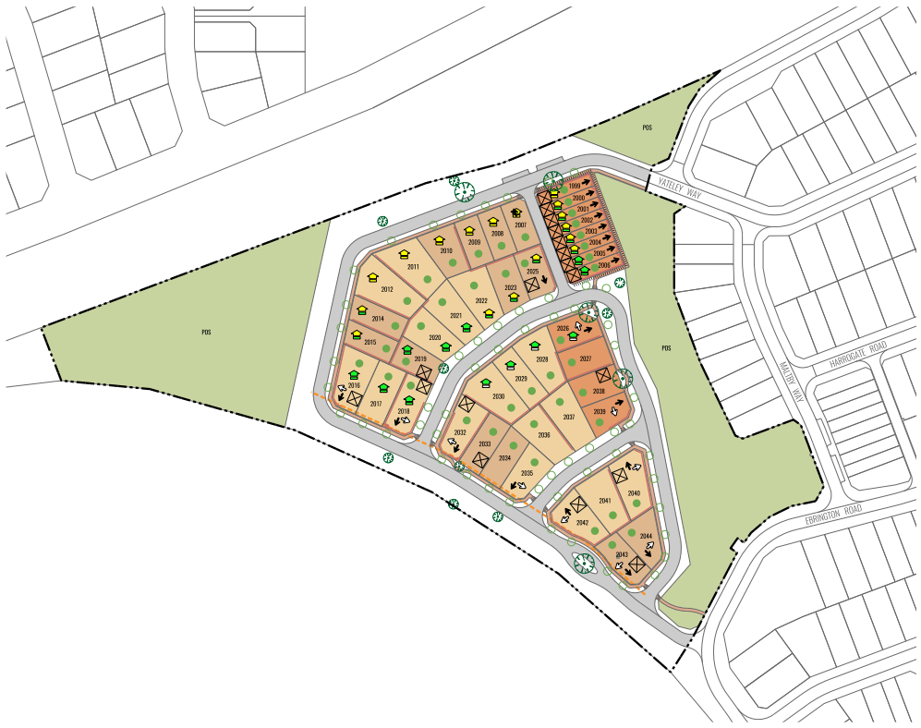

Aerial image of Stage 49 (showing Leda to the North) hatched area indicating new Wellard location:

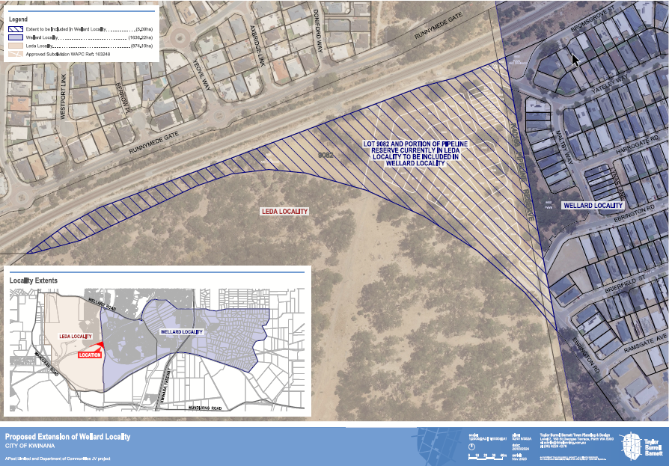

Strategic Implications

This proposal will support the achievement of the following outcome/s and objective/s detailed in the Strategic Community Plan and Corporate Business Plan.

Strategic Community Plan
Outcome | Strategic Objective | Action in CBP (if applicable) | How does this proposal achieve the outcomes and strategic objectives?
3 – Infrastructure and services that are affordable and contribute to health and wellbeing | 3.2 – Provide for an accessible and well connected City by integrating public transport and improving safe streets for driving, walking and cycling | N/A – There is no specific action in the CBP, yet this report will help achieve the indicated outcomes and strategic objectives | This proposal is intended to ensure emergency services are not delayed in accessing future residential lots within the area in question by ensuring their locality name reflects their geographical proximity to, and limitation on road access via adjoining Wellard.

Social Implications

This proposal will support the achievement of the following social outcome/s, objective/s and strategic priorities detailed in the Social Strategy.

Social Strategy
Social  Outcome | Objective | Strategic Priority | How does this proposal achieve the social outcomes, objectives and strategic priorities?
4 – Safe and Resilient | 4.0 – Safe enjoyment of community life | 4.7 – Plan and prepare for emergency management, recovery and community resilience | This proposal is intended to ensure emergency services are not delayed in accessing future residential lots within the area in question by ensuring their locality name reflects their geographical proximity to, and limitation on road access via adjoining Wellard.

Legal/Policy Implications

There are no direct legal/policy implications arising from this recommendation.

Financial/Budget Implications

There are no direct financial/budget implications arising from this recommendation.

Asset Management Implications

There are no direct asset management implications arising from this recommendation.

Environmental/Public Health Implications

There are no direct policy implications arising from this recommendation. As indicated above, it will provide assistance to emergency services when accessing the area upon completion of Stage 49.

Community Engagement

The area impacted is currently vacant land. No community members will be directly impacted by the proposed locality change.

Attachments
A. Letter from Taylor Burrell - Locality Change Request - Stage 49 The Village at Wellard - 28 February 2024

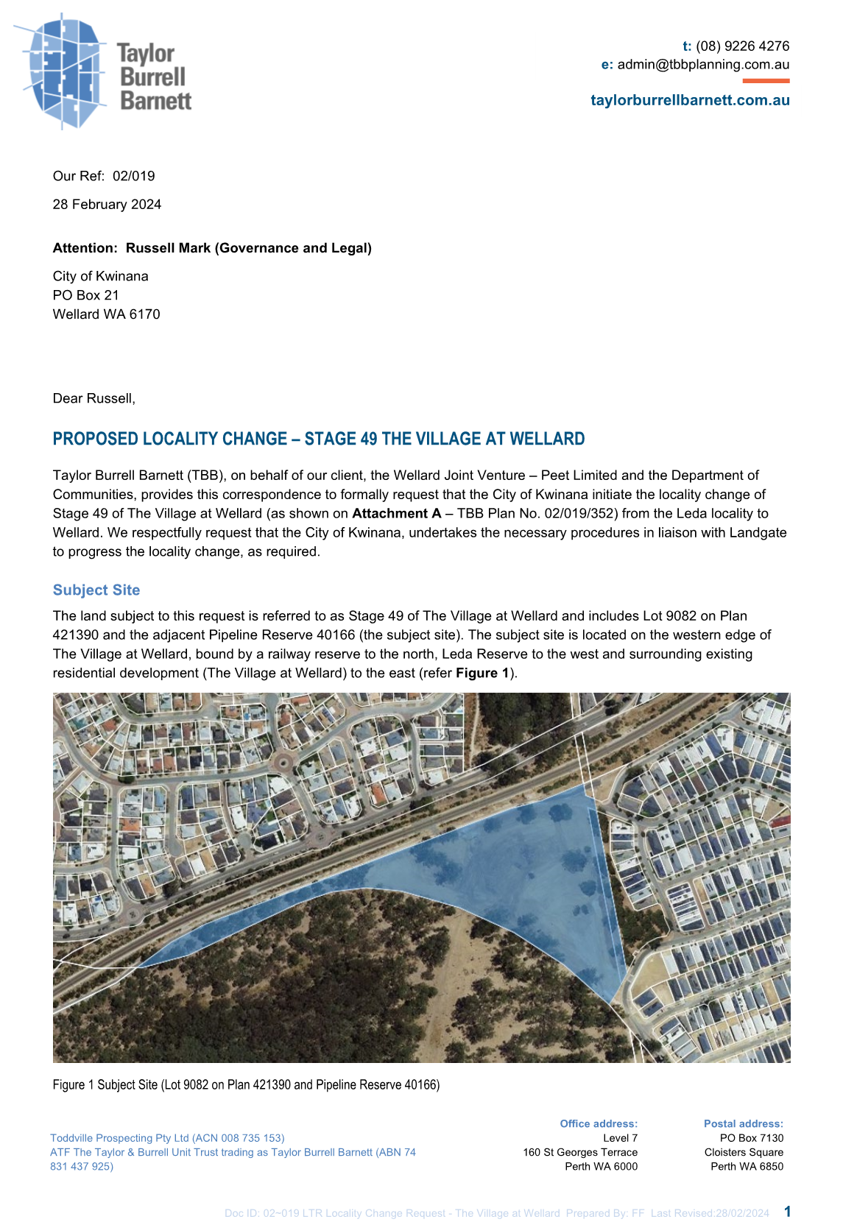
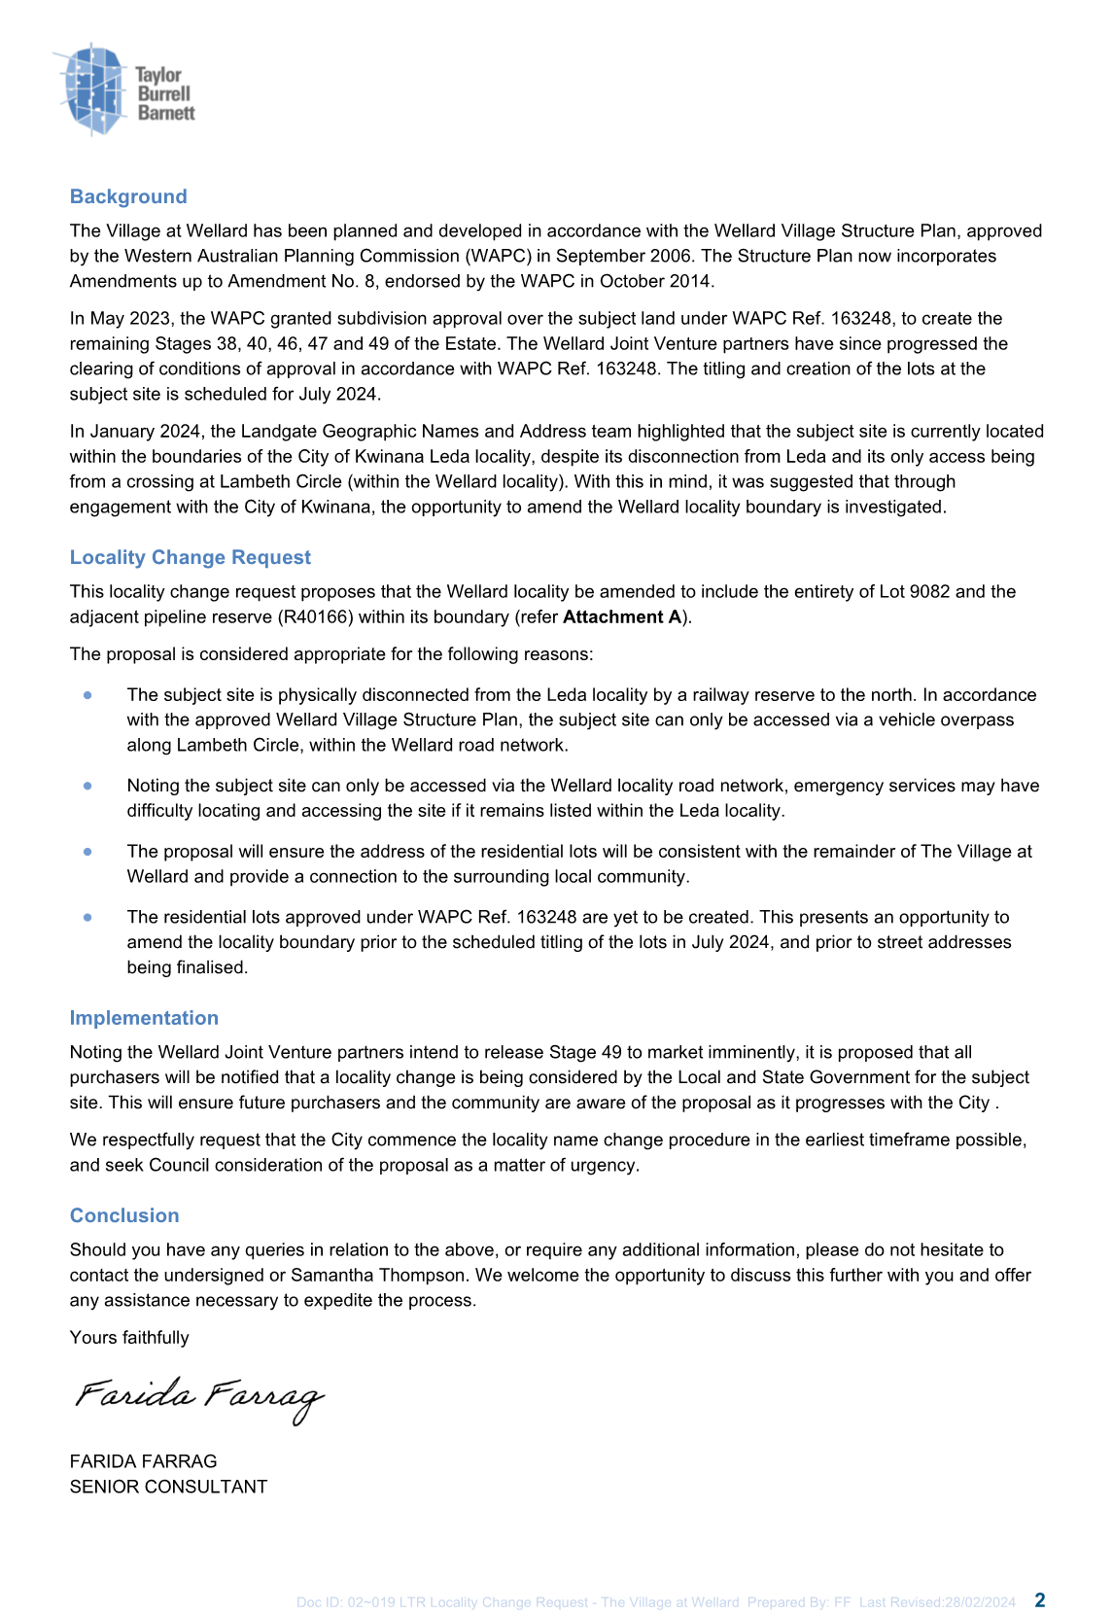


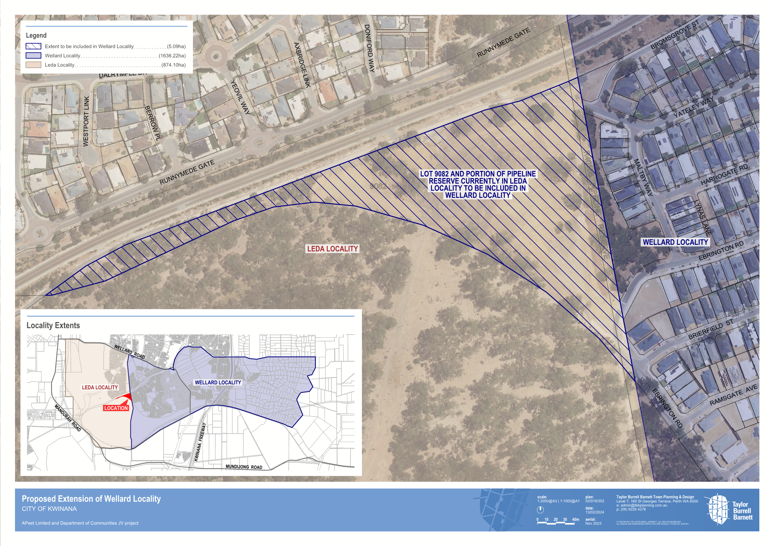

16 Reports – Natural Environment
Nil

17 Reports – Built Infrastructure
Nil

18 Reports – Civic Leadership
Nil

19 Notices of Motions of which Previous Notice has been Given
Nil

20 Notice of Motions for Consideration at the Following Meeting if Given during the Meeting

21 Late and Urgent Business
Note: In accordance with Clauses 3.13 and 3.14 of Council’s Standing Orders, only items resolved by Council to be Urgent Business will be considered.

22 Reports of Elected Members

23 Answers to Questions which were taken on Notice

24 Mayoral Announcements

25 Confidential Items
Nil

26 Close of Meeting

